**HashMaps & HashSets**

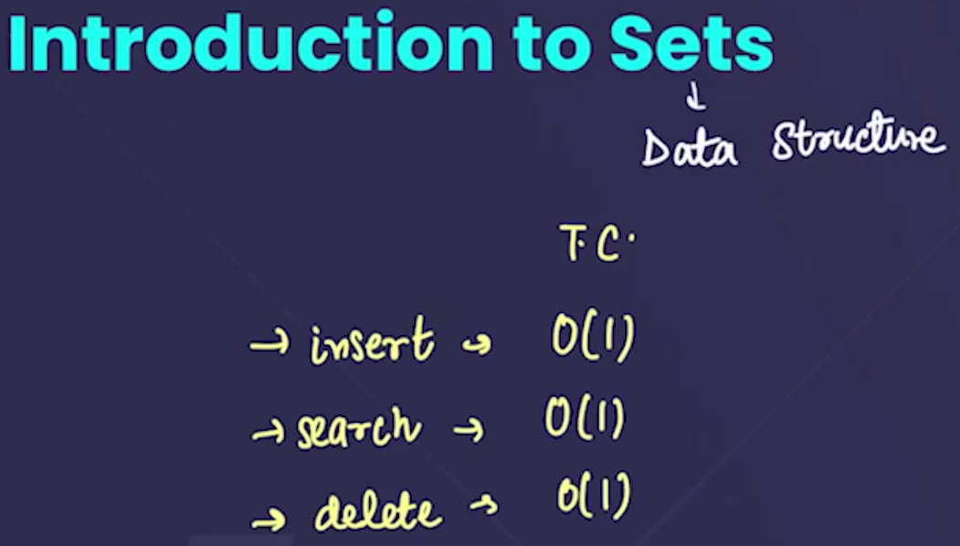

* It is a data structure having very less time complexities in different operation:
  + To insert=O(1)
  + To search=O(1)
  + To delete=(O(1)
* In sets , the elements are randomly stored, there is no particular pattern for storing the elements.

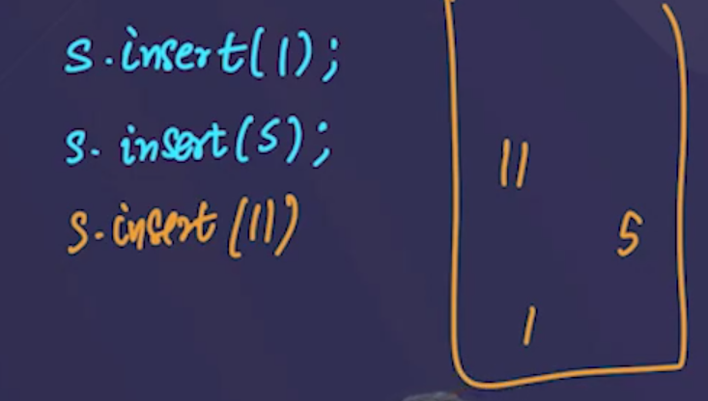

* 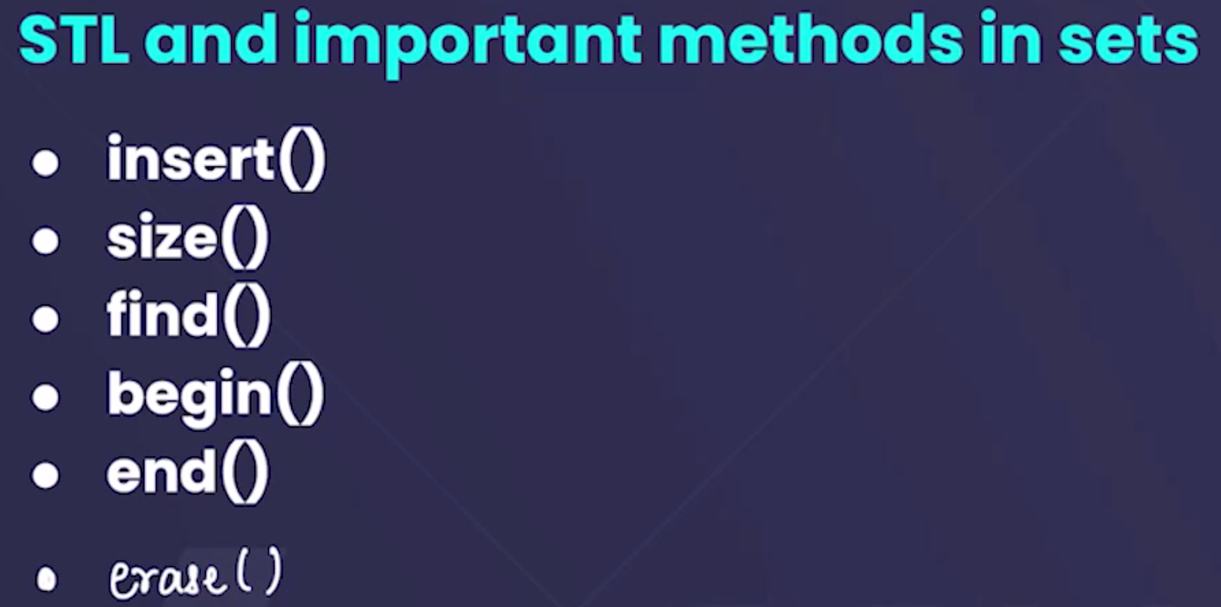
* To include the sets in our program we need to use: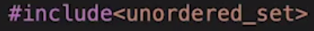
* Since we know that elements in the sets are randomly arranged, so we cant print its elment using for loop, we need to use **for each loop**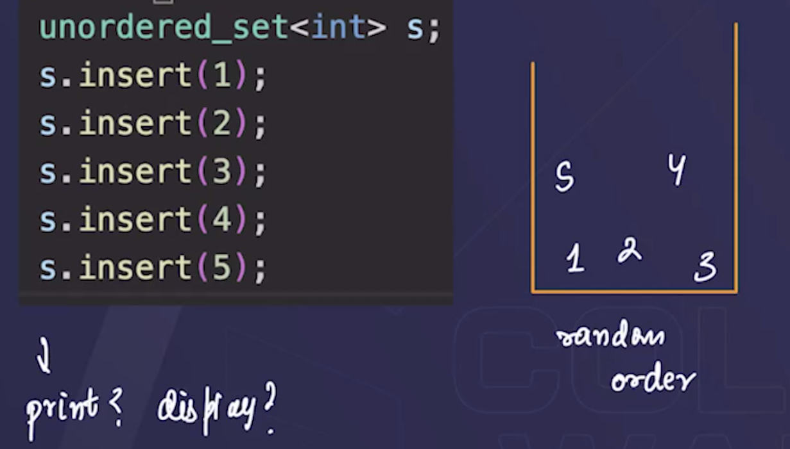
* Sets m hm **Unique elemets** ko hi store krwaa skte h🡪for example, agar hm kissi elements ko set m 2 baar bhi insert kr dete h, lekin while printing woh ek hi baar show krega.
* **S.size() 🡪** it is used to print the size of the set, but it excludes the duplicate elements, i.e, it dosent count the duplicate elements.
* **S.erase(ele)🡪** it is used to delete the element from the set.
*  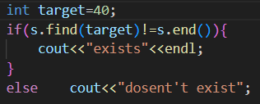🡪learn this format of finding the element in the set.
* 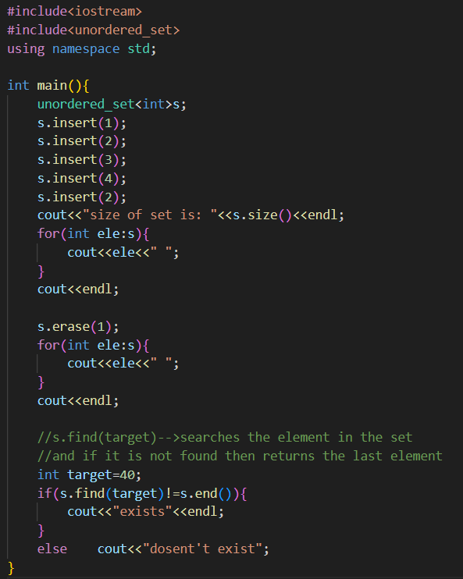

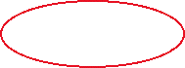

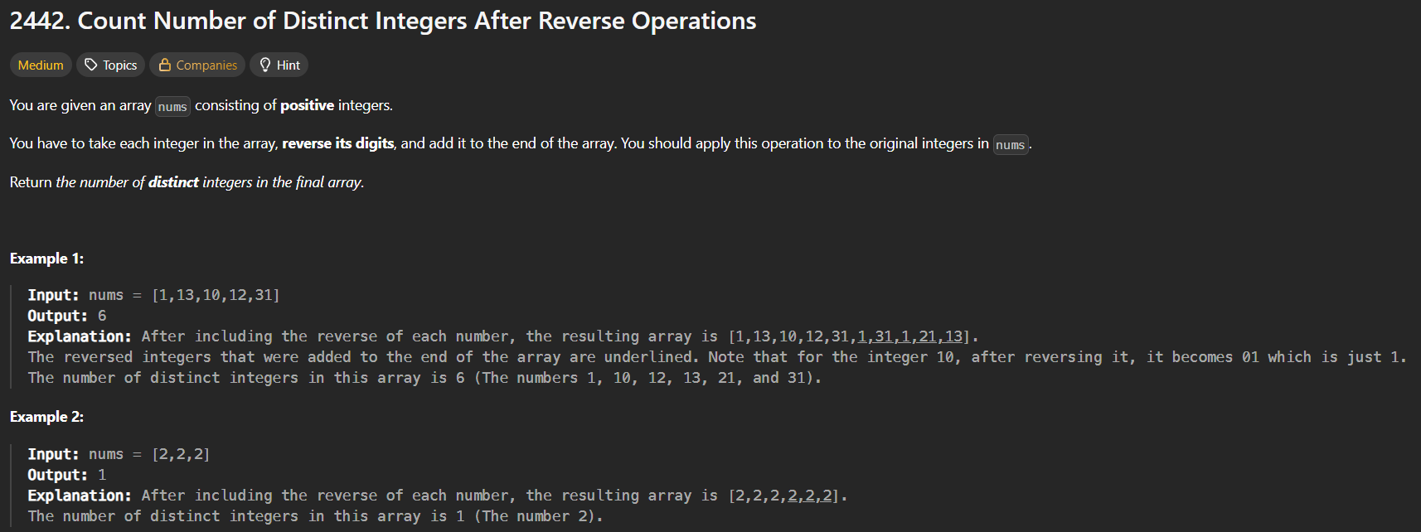

* 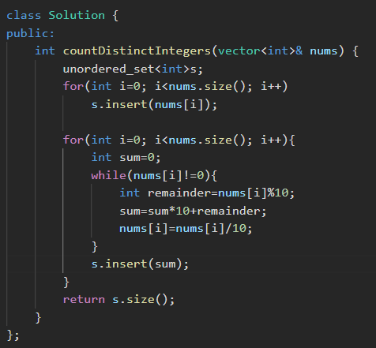**🡪**pehle saare elements from the original array, ko push krdo in the sets( sets m whi sb elements push hoga jo unique h), and then numbers ko reverse kro and ussi time set m insert krwaa do, last set m sirf unique elements present honge, last m sets.size() return krwaa do.

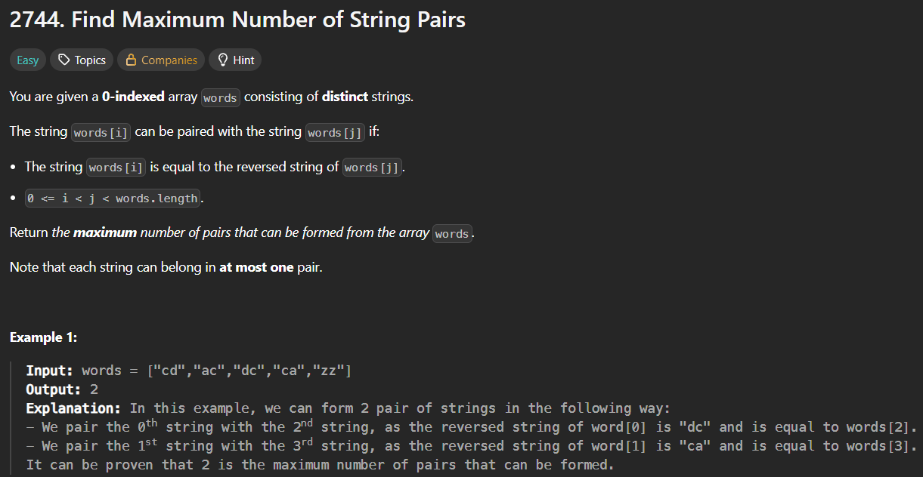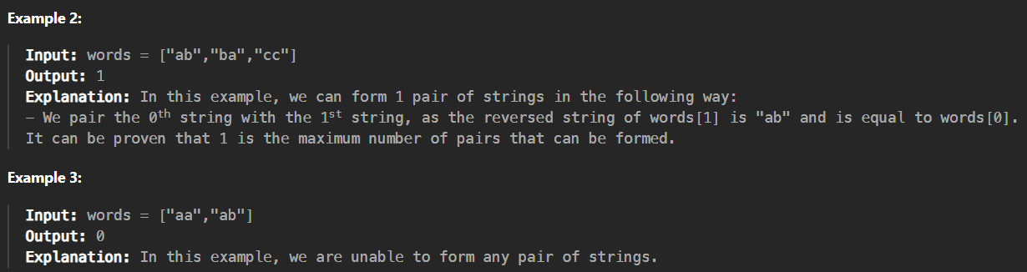

* **Method 1: 🡪O(n^2)**

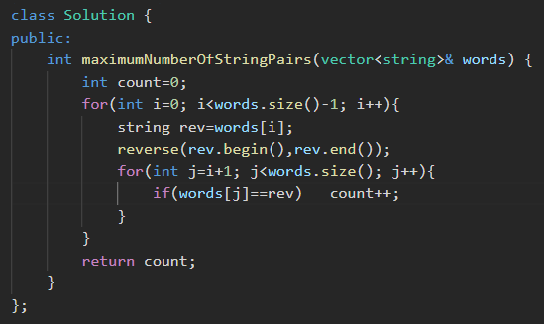

* **Method 2:🡪using sets🡪 O(n)** 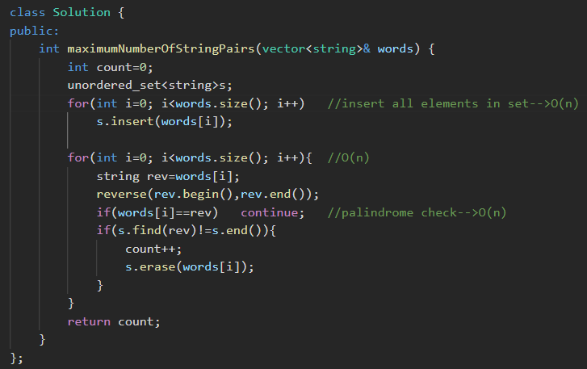🡪pehle saare elements ko ek set m daal do, then for each element reverse it, and check whether it’s reverse is present in the set or not, if present the🡪count++ , and erase that string from the array.
* **Method 3:**

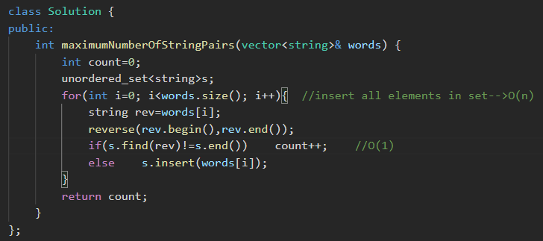🡪similar as above method, just reduced some step.

**HashMaps**

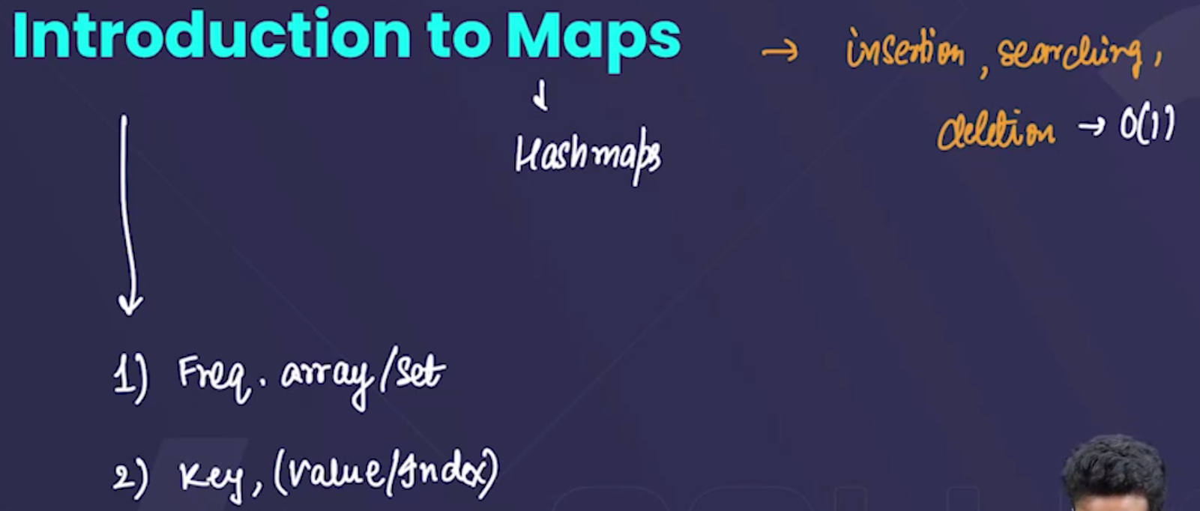

* In the hashMaps also, the operations of insertion, searching, and deletion have the time complexity=O(n).



* To include the map in ur program we use 
* There is also a feature in C++, that we can make a key:value pair, directly 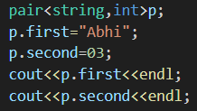 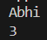



* Similarly, we can make the key:value pair using the maps also.
* The best example to make the haspMaps is that we can use it to store the details of employees(Name: id), details of student(Name:roll_no), etc
* 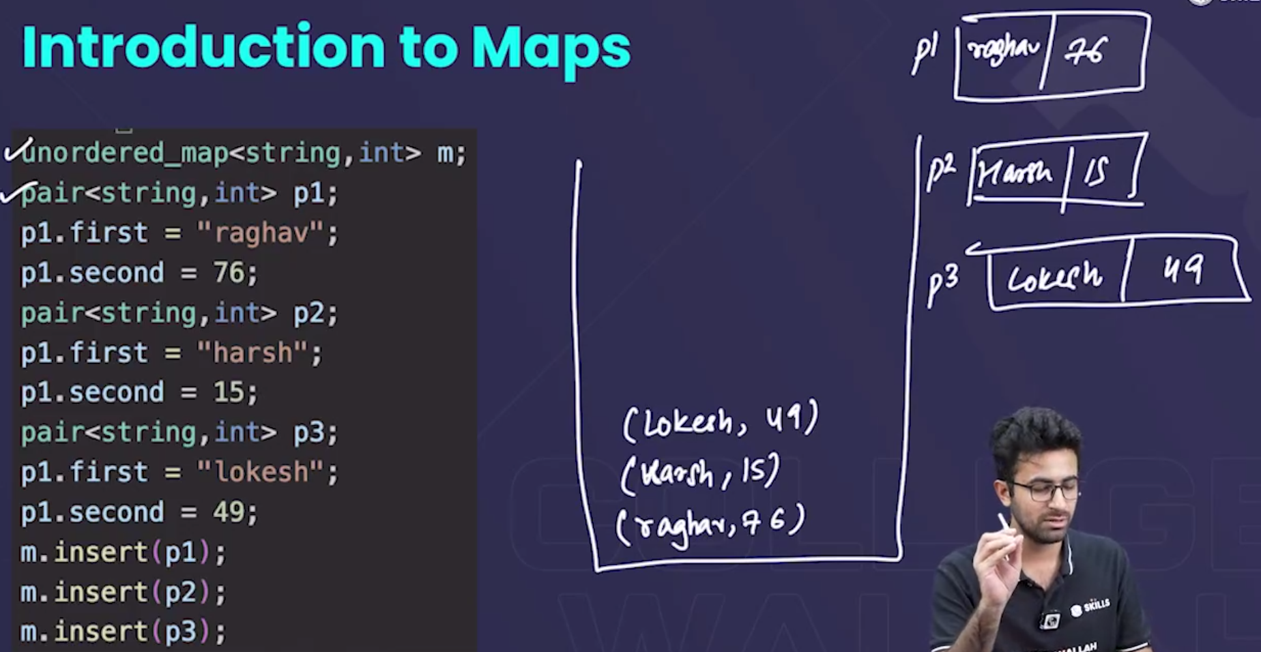
  + jb hmne pair bnaaya, to paisa aisa bnta h and jb hm usko insert krte h, then woh as a pair insert ho jaata h in the map.
  + We can also print the elements of the map using **for each loop** also while, using here for each loop, hm wha int nhi likhegenge **pair** likhenge , becox hm element ko nhi, pair ko access krne ki koshis kr rhe h.
  + Note: while printing the elements of the map, yehh jaroori nhi h ki, saare elements line se hi print ho, elements randomly print hota h. 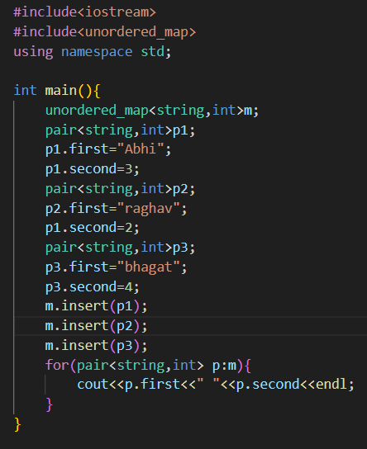 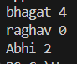



* + Note: In **for eachloop**, when we access the elements of the loop, hm wha dataType likhne k jagah p directly “**auto keyword”** likh skte h , usse automatically detect ho jaata h ki kon sa dataType h. 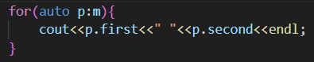
  + Another method to insert the element into map directly: 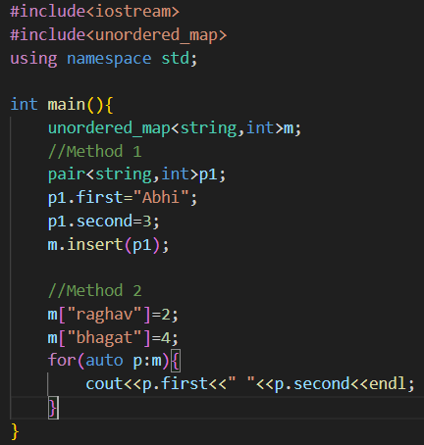 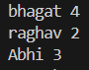

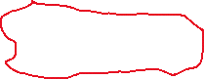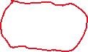

* + To delete the elements of maps: 
  + To print the size of the maps: 
  + 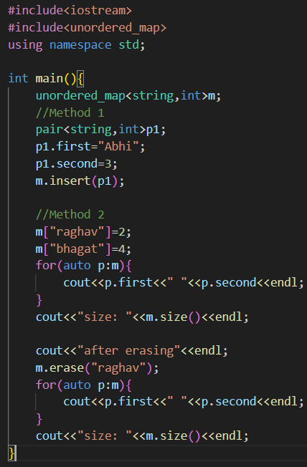 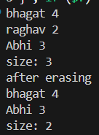 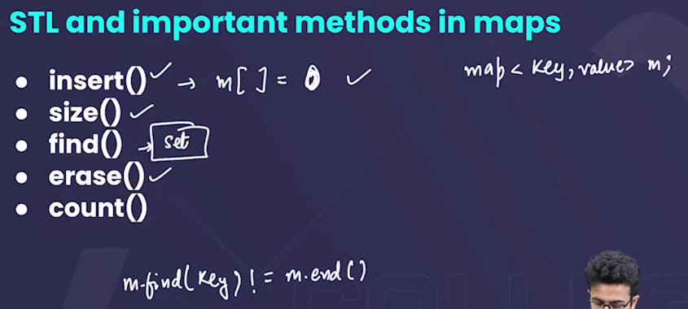



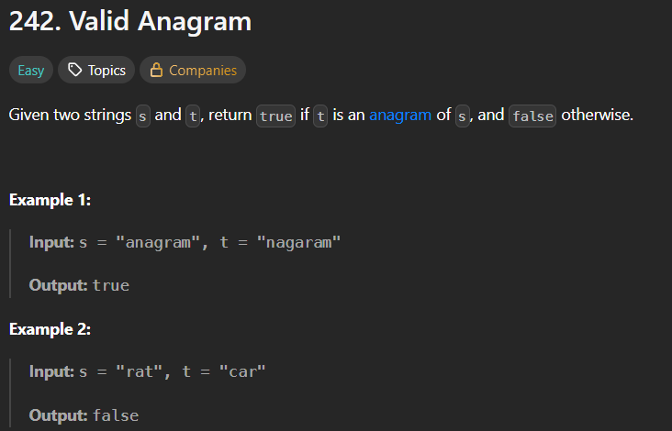

* Anagram means ek word k saare letters ko use krke doosra word bnaaya ja aske.
* Method 1: 🡪using sorting 🡪T.C=O(nlogn)

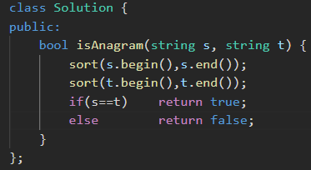

* Method 2: 🡪using hashMaps🡪T.C=O(n)
  + By counting the frequencies of the letters occurring i.e, how many times the letters occur.

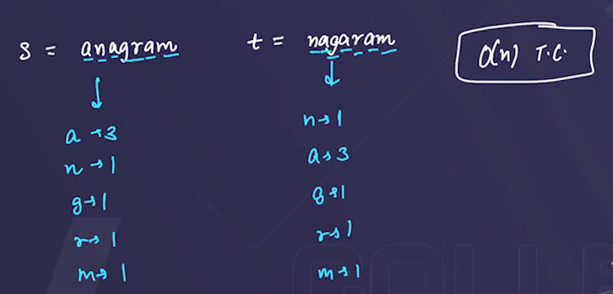

* + Algorithm: Make map1 & map2 , and by using for each loop, traverse on the string and count the frequencies of each letter. 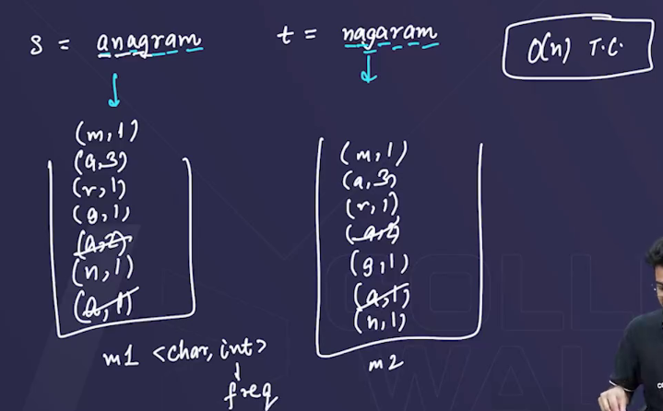
  + Dry run: 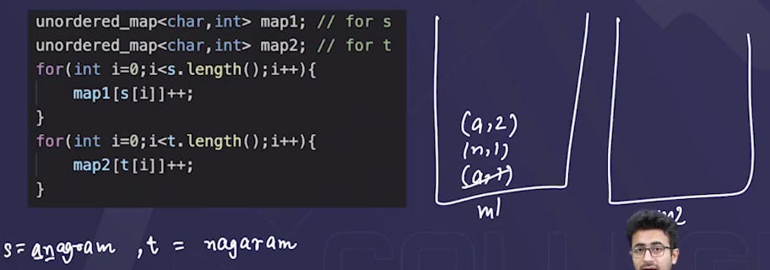
  + 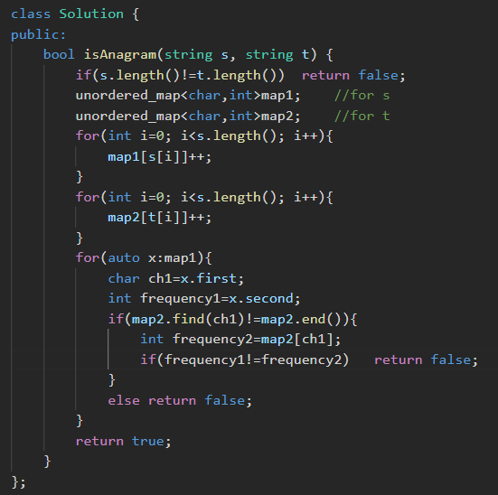
* Method 3: 🡪using single hashMap🡪T.C=O(n)

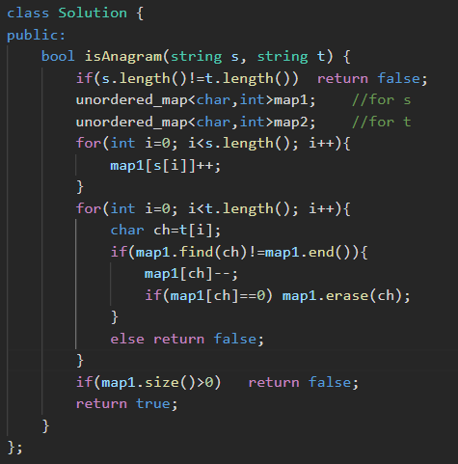

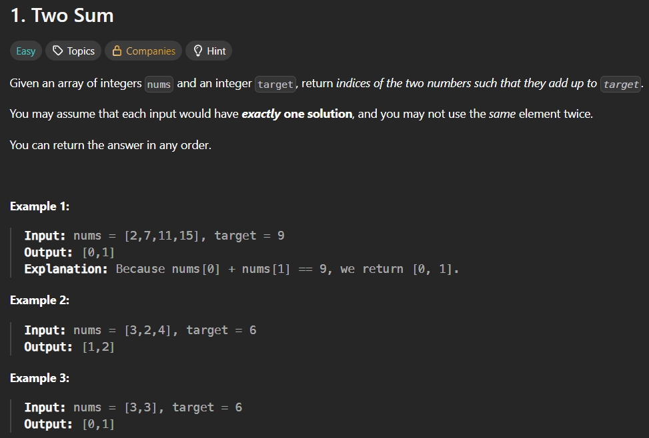

* Method 1: 🡪O(n^2)

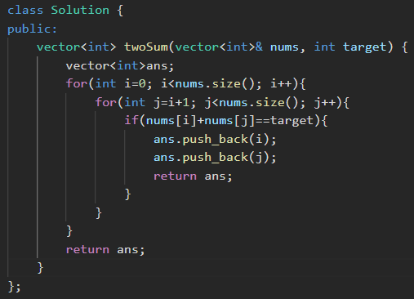

* Method 2: using hashmaps🡪O(n)

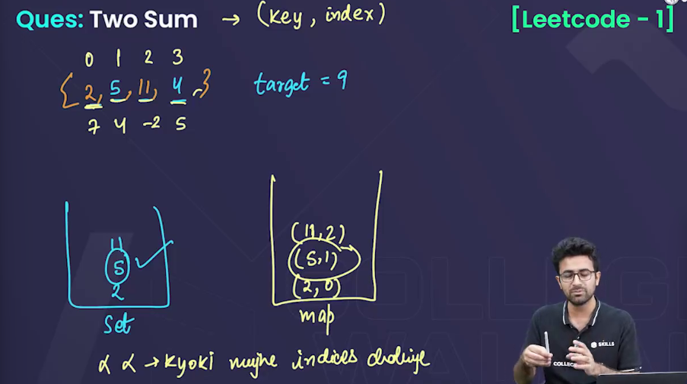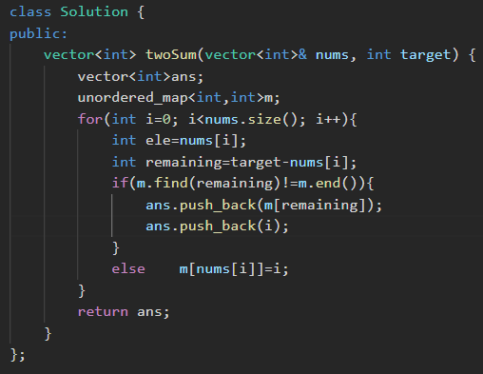

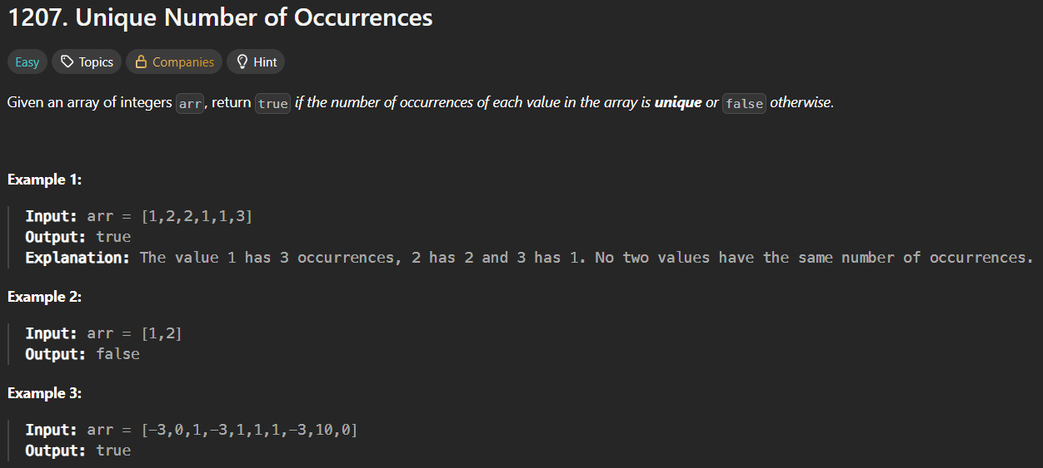

* 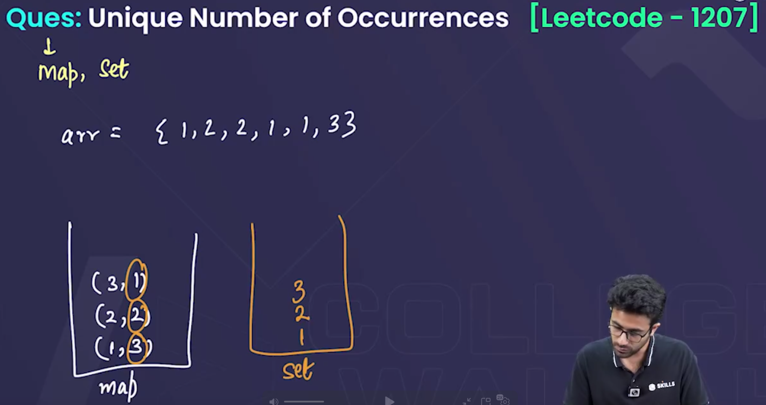
* 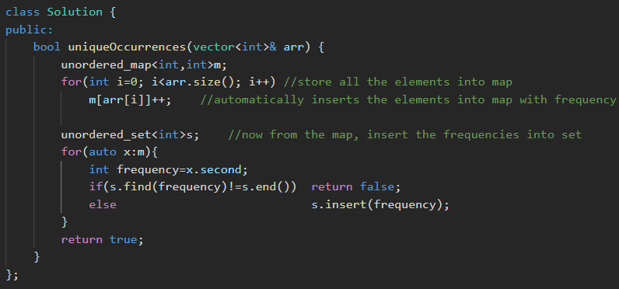

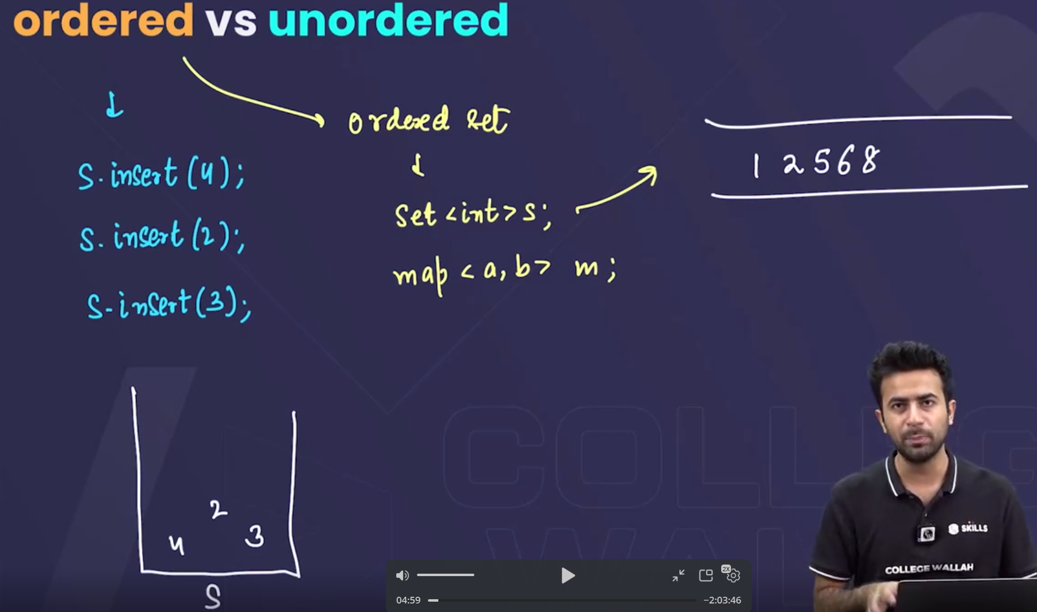



* In unordered set, jb hm elements ko insert krte h, to woh randomly khi bhi jaake insert ho jaate h, in the set🡪but sirf unique elements hi insert ho paate h.
* But in ordered set, jb hm elements ko insert krte h, to woh sorted order m insert ho h, in the ordered set. 🡪but sirf unique elements hi insert ho paate h.
  + For eg: hmne pehle 1 insert kiya , to 1 insert ho jaayega, the 5 insert kiya , to 5 1 k baad insert ho jaayega, but jb hm 2 insert krenge , to 2🡪 1 or 5 k beech m insert ho jaayega, similarly it goes on ….

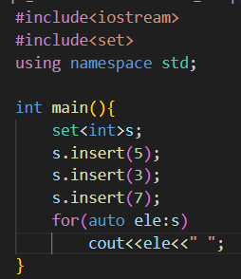 

* + all the things in the ordered set, are similar to unordered set, but the difference is that:
    - the elemets in the ordered set are inserted in the sorted order.
    - The operations in the ordered set(insertion, deletion, find, …) don’t have time complexity=O(1), they have **Time coplexity=O(logn)**

**Ordered map:**

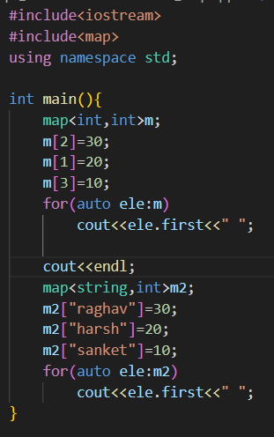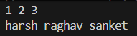

* In ordered map also, the elements are sorted, but they are sorted on the basis of the keys, not the values.

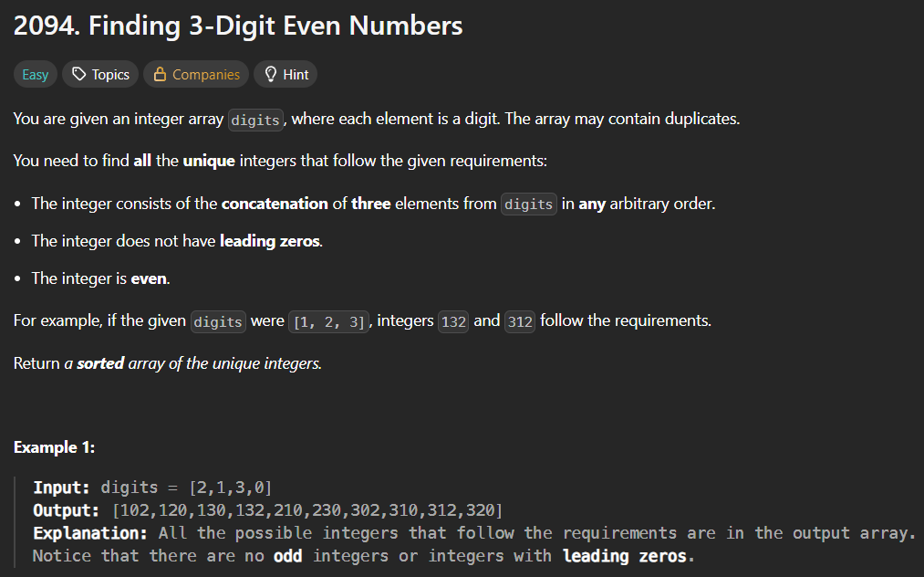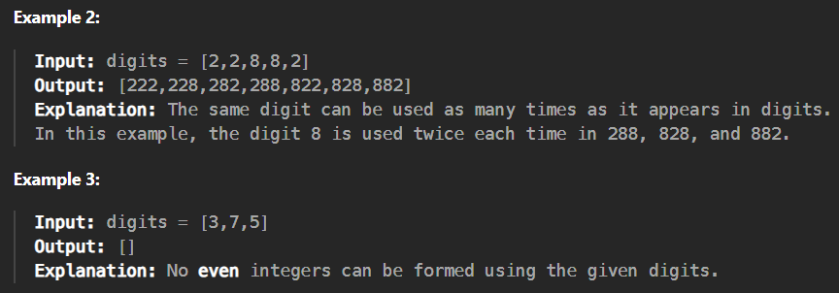

* 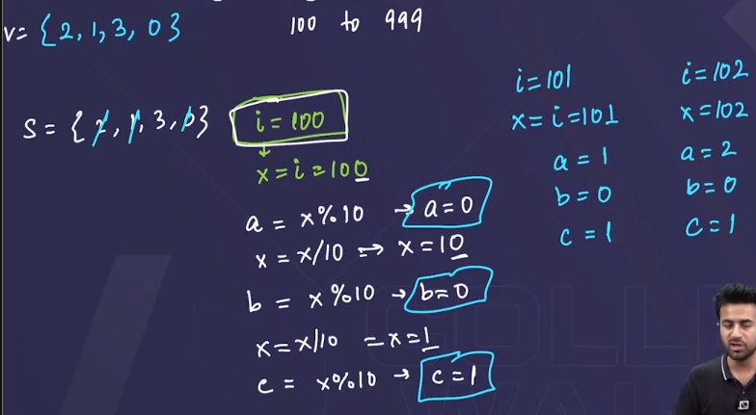🡪Algorithm: 100 se lekar 999 tk loop chalaoo, and then for each number, unke saare digits ko nikaalo, and check kro ki woh digits sets m h ki nhi, if h then woh number form ho skta h from the given digits and push that number in the “ans” vector.
* 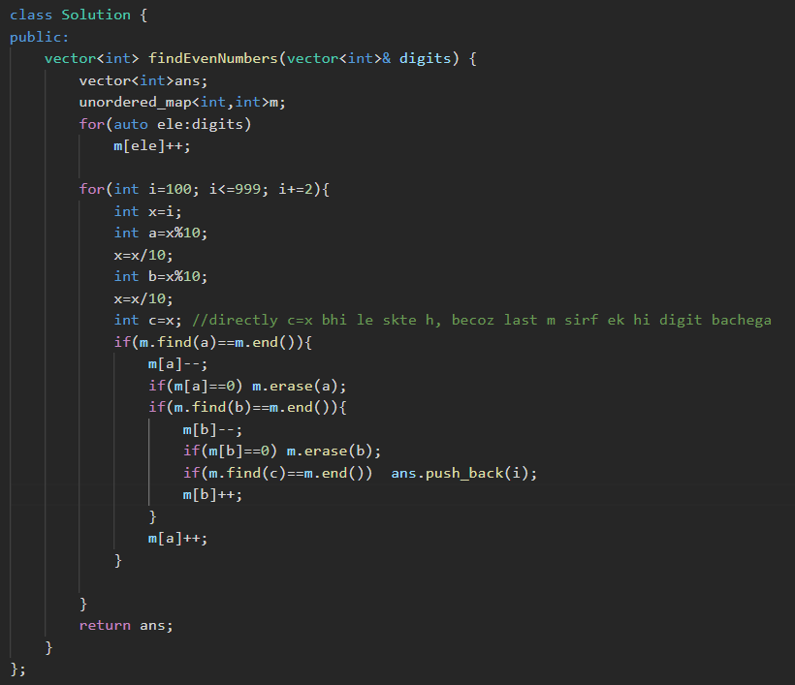🡪this program not runs(shows errors)

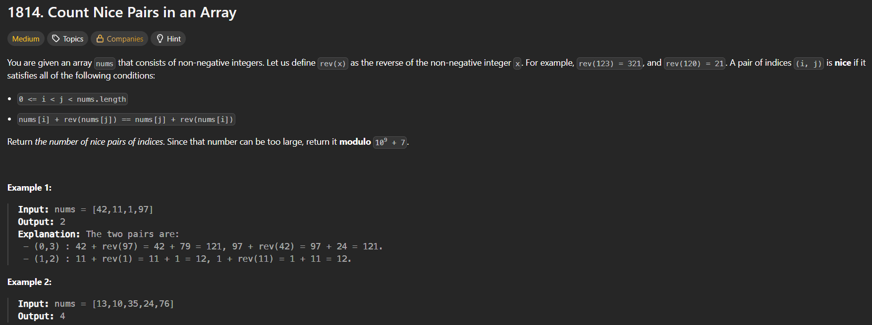

* Method 1:🡪my method 🡪time limit exceeded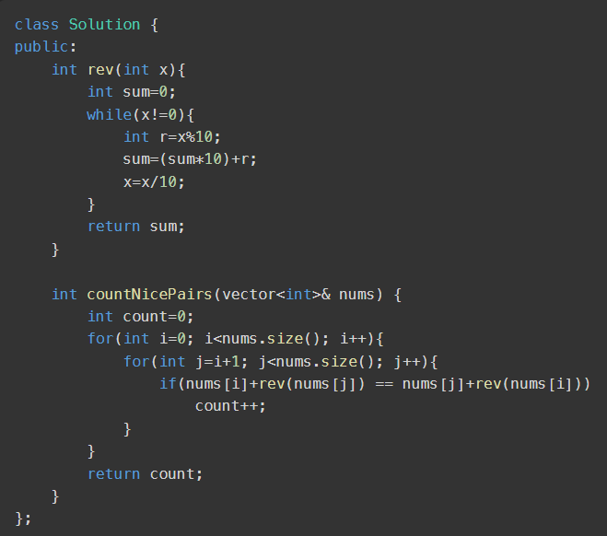



* Method 2:🡪 gives runtime error

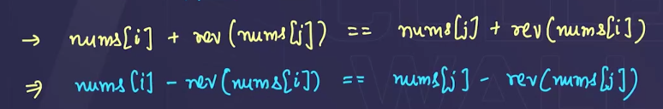 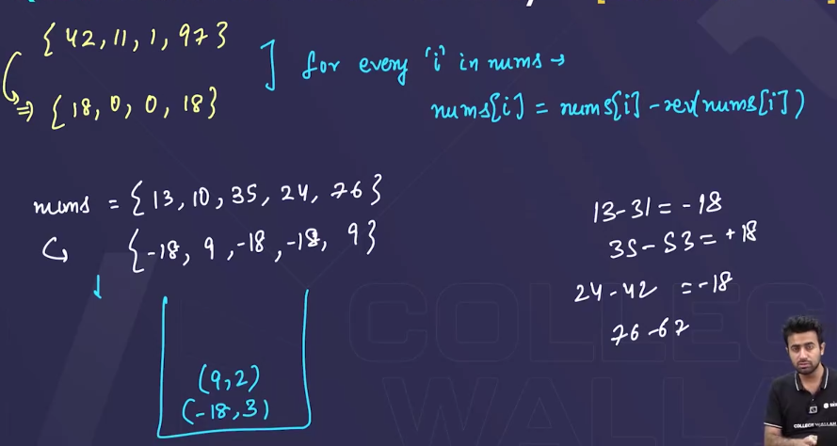

🡪step 1: 1st saare numbers ka reverse nikaal k unke saath,subtract kr do, isse hme yehh pta chal jaayega ki pairs bnenge.

🡪now map m saare elements ko daal do , isse hme yehh pta chal jaayega ki kon sa

Number kitne baar aaya h.

🡪then suppose koii, number 3 baar repeat hua h, then hm by using **3C2** yehh dekh skte

H ki kitna pair bnega.

🡪 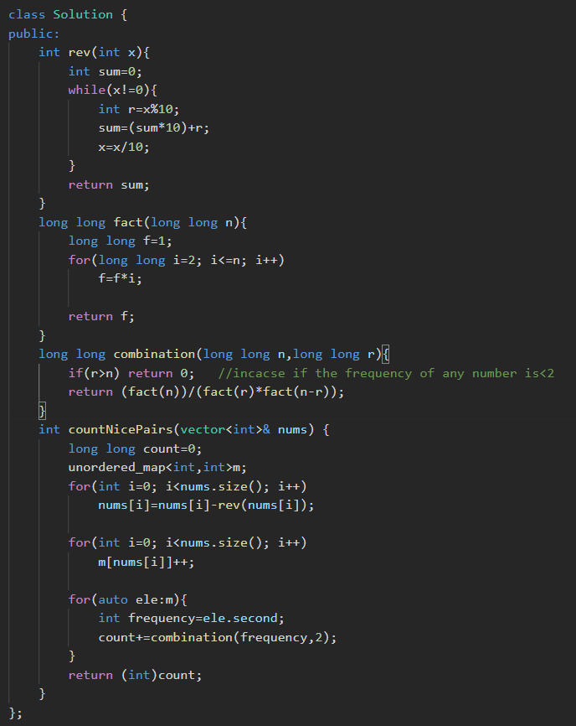 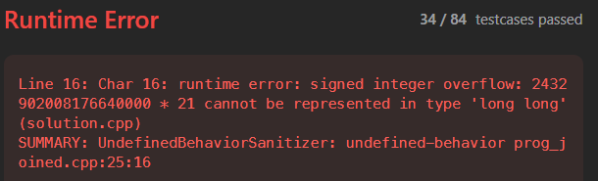

* Method 3🡪using maps

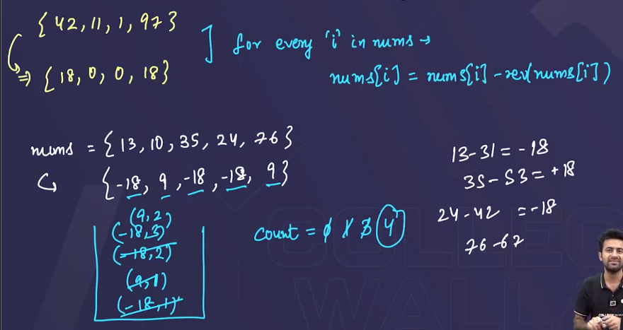

🡪step 1: 1st saare numbers ka reverse nikaal k unke saath,subtract kr do, isse hme yehh pta chal jaayega ki pairs bnenge.

🡪now map m saare elements ko daal do , isse hme yehh pta chal jaayega ki kon sa

Number kitne baar aaya h, but map m jab daalenge element ko, ussi time yehh check

Krte rhenge ki pehle se who number h ya nhi , ar agar h to kitne baar h, jitne baar pehle

Se present hoga utne baar(frequency) , count m add krte jaayenge, kyunki utne pair ar

Pair bn skte h.

* 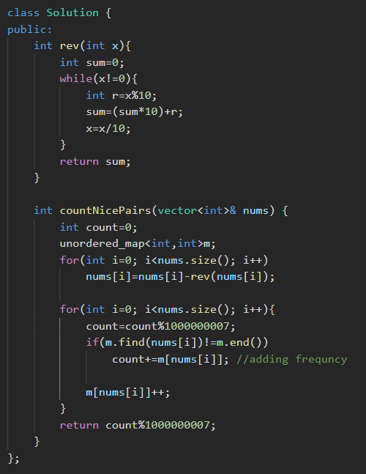🡪this is becoz, it is mentioned in the question that count can be very large, so return it by using modulo with this number.

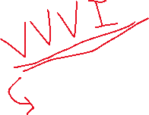



* **For placement**.
* 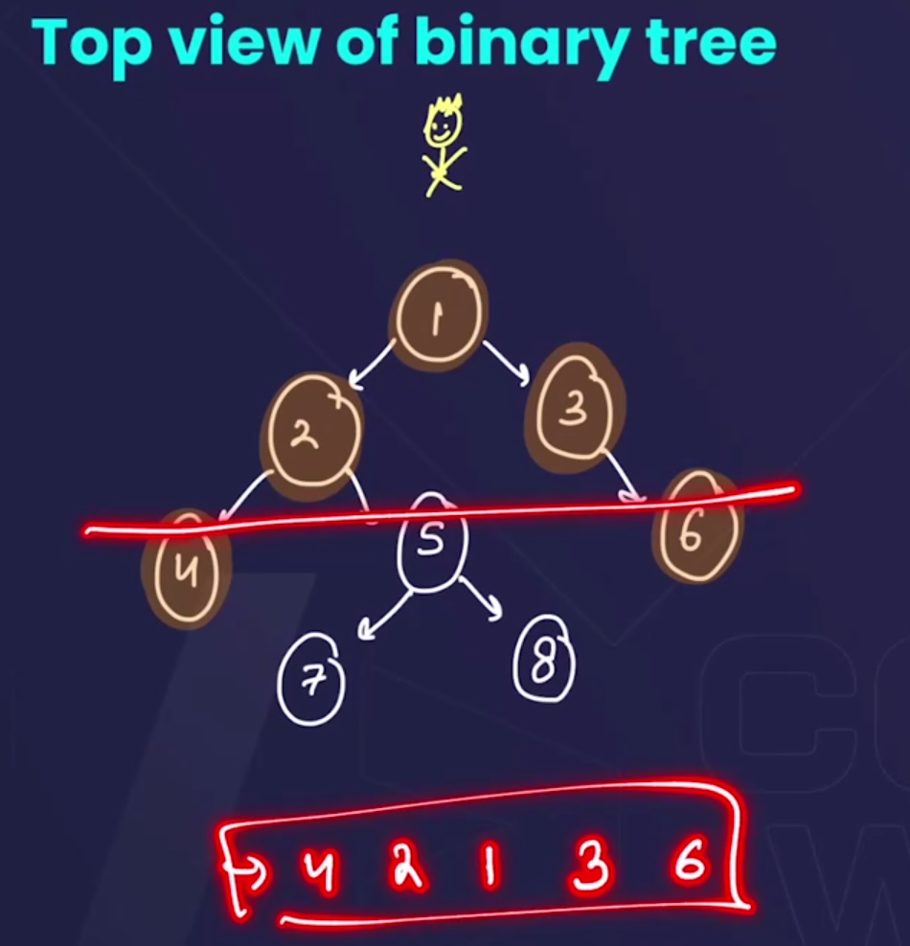
* 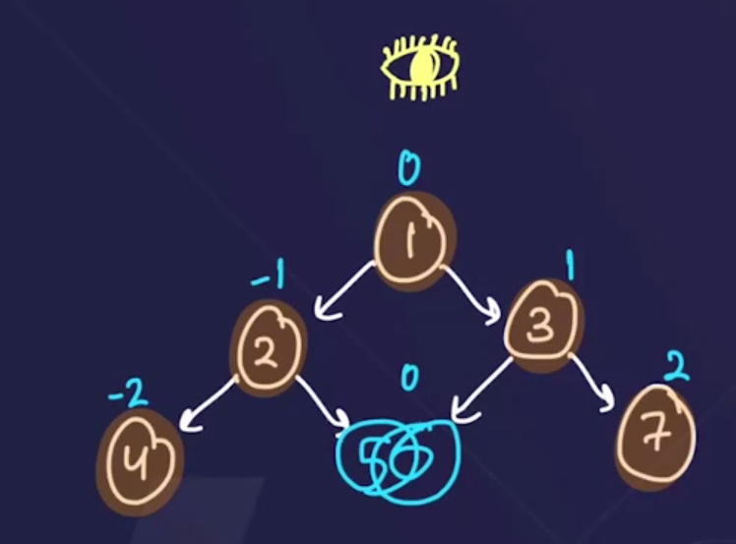
* Algorithm:

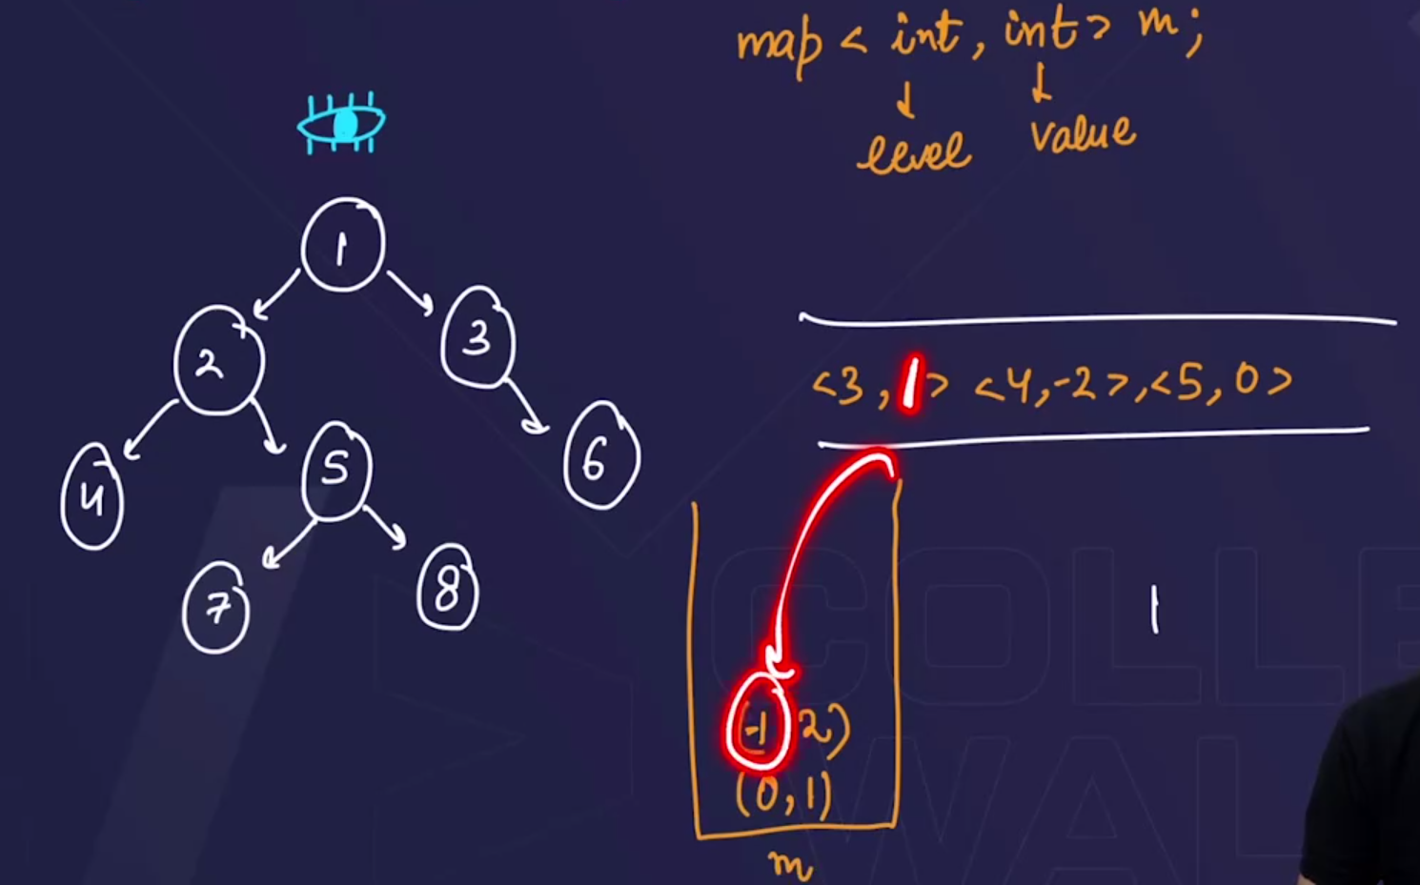🡪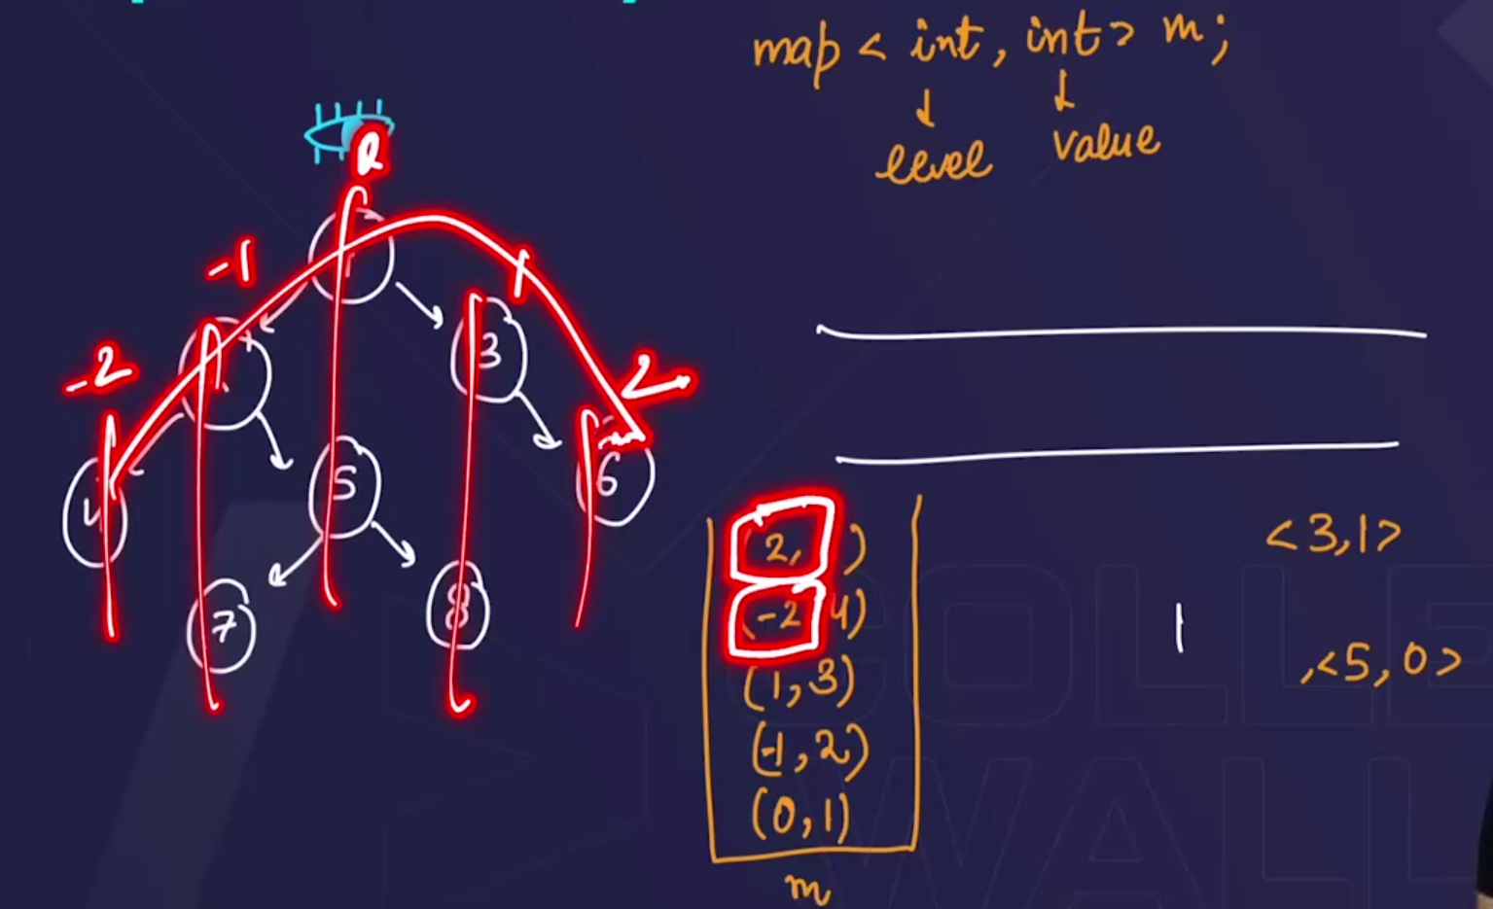

🡺Pehle ek queue bnaoo, then usme values ko daalo, with (value,level).

🡺Then Ek hashmap bnaoo, then usme, values ko daalo, from the queue, 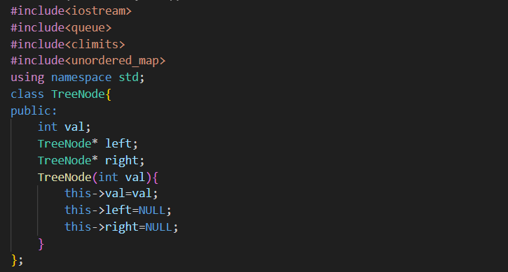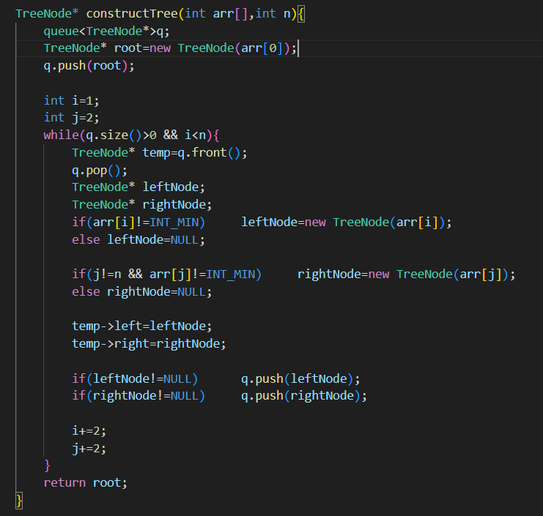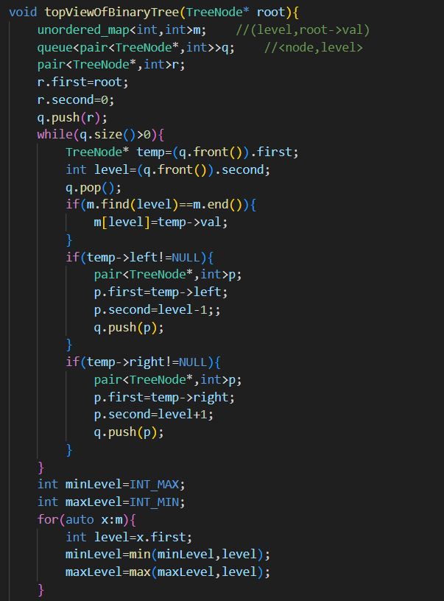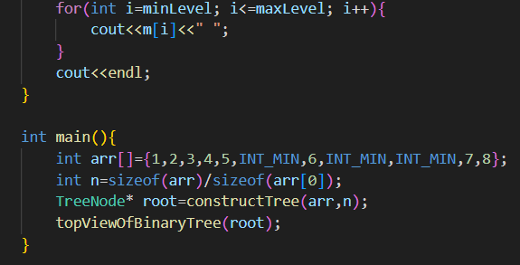

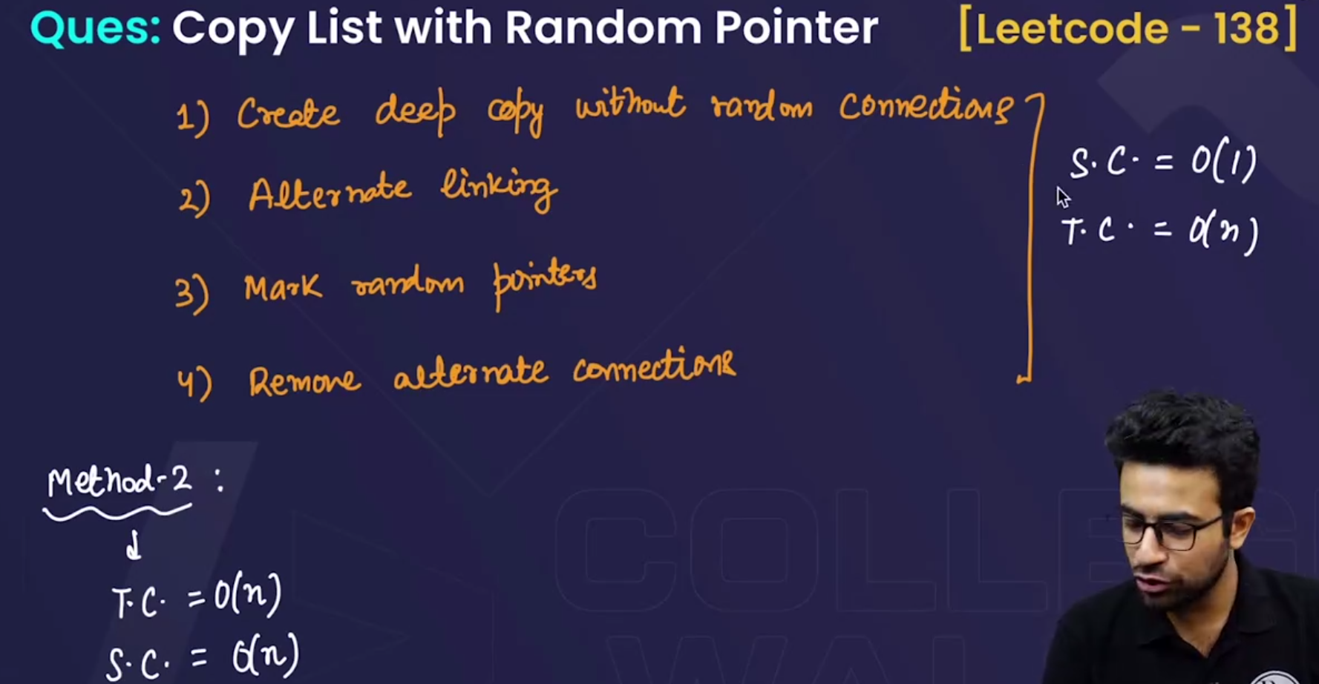

* Method 1🡪using linked list🡪T.C=O(n)🡪S.C=O(1)🡪but very tough. 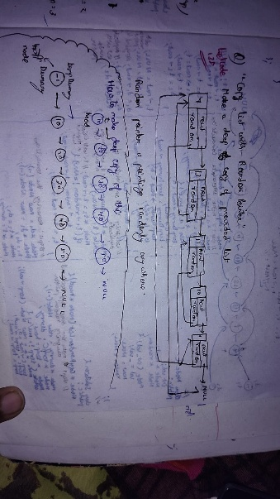 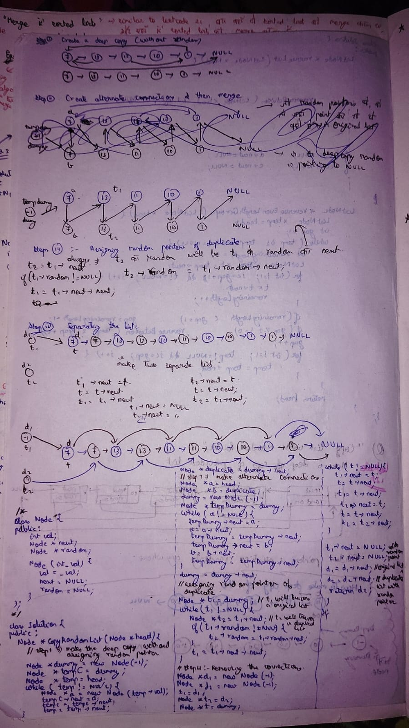

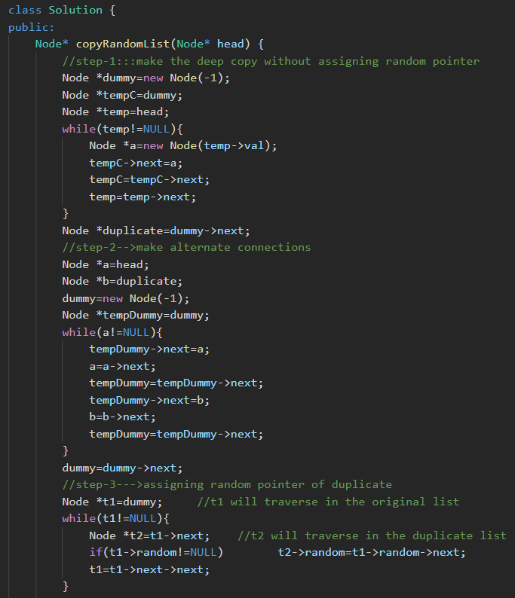

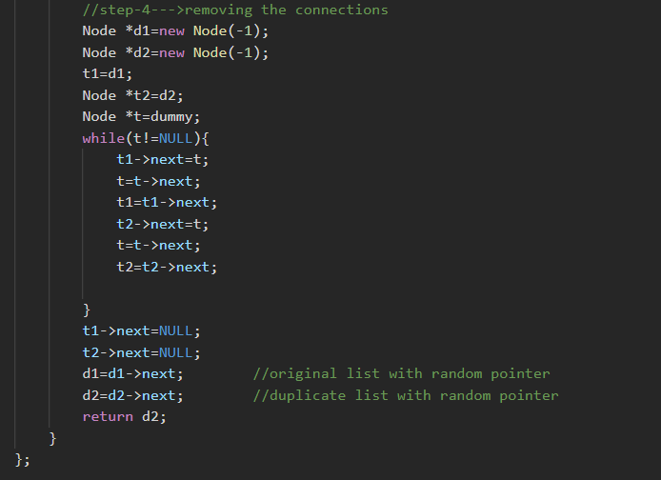

* Method 2🡪using hashmaps🡪T.C=O(n)🡪S.C=O(n)🡪easier than linked list method. 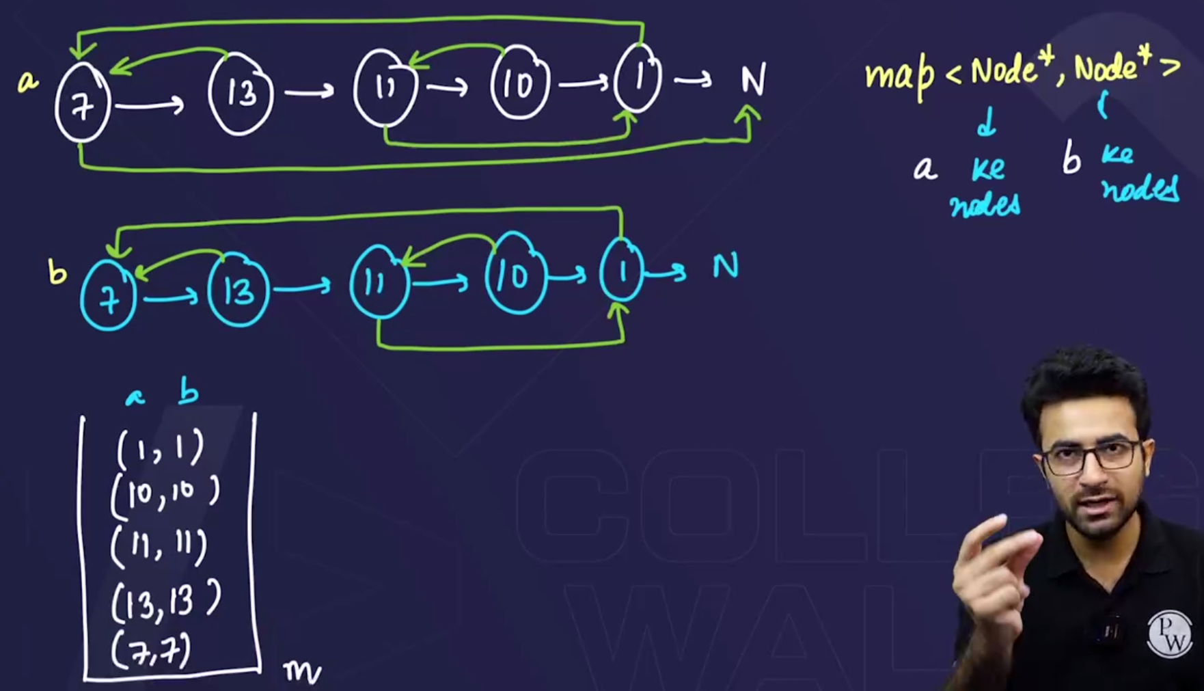 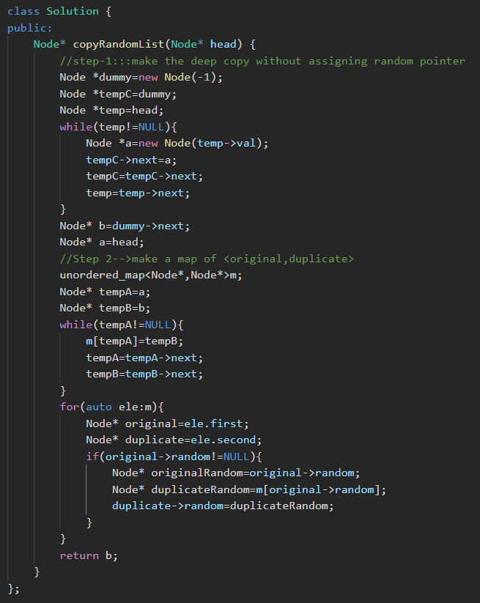

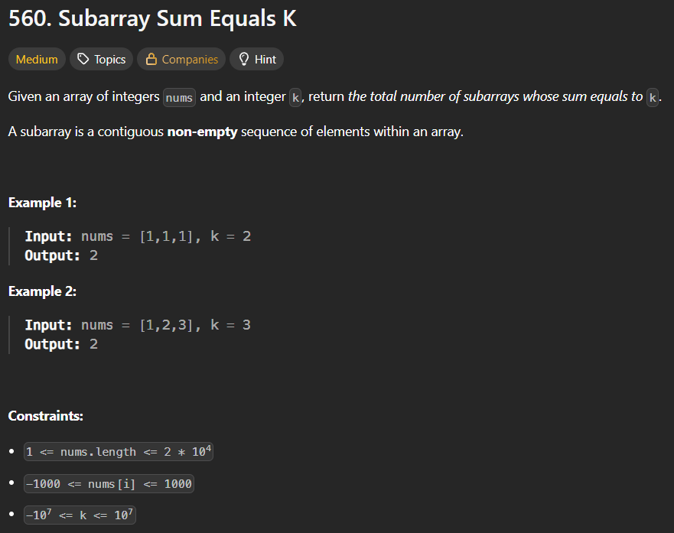

* Method 1🡪using prefix sum 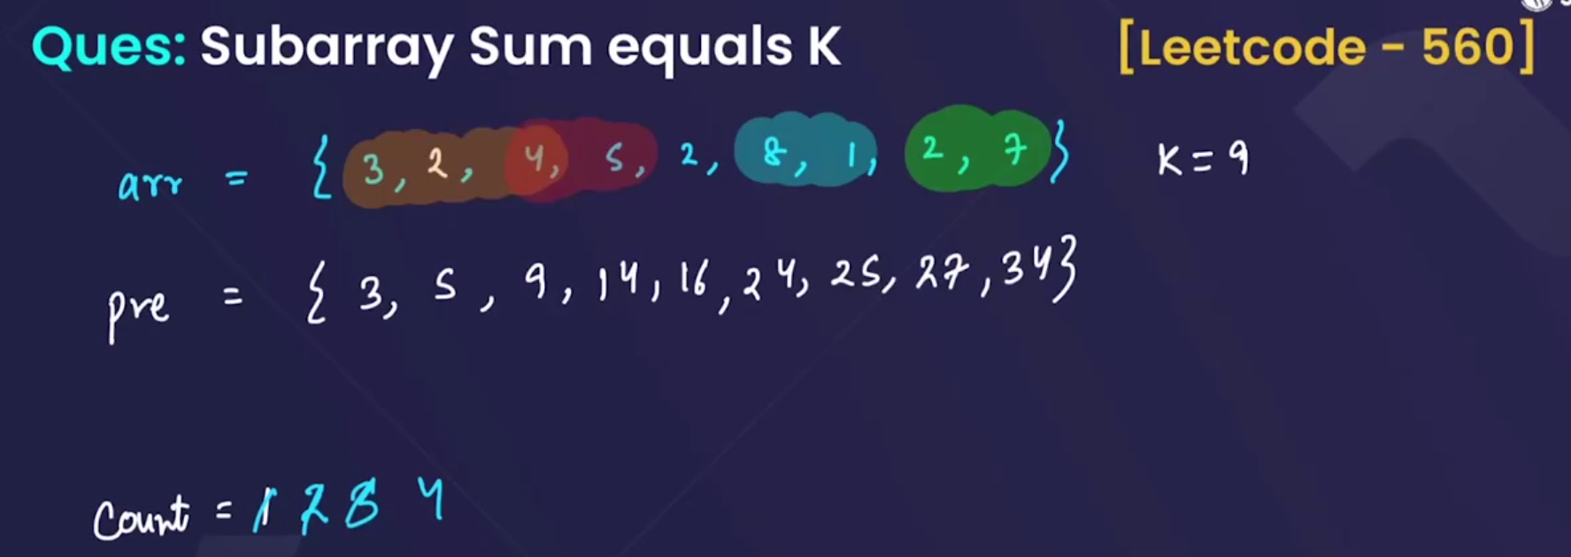

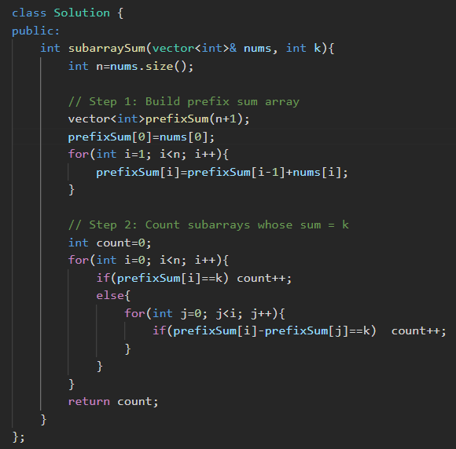 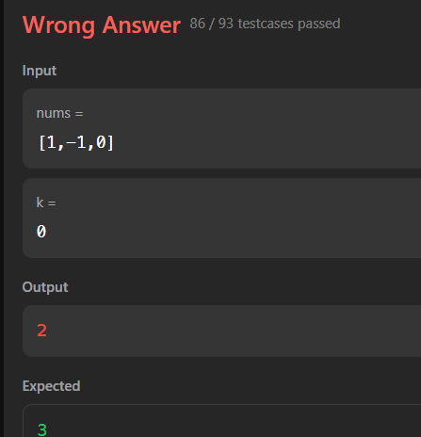

* Method 2🡪using hashmaps

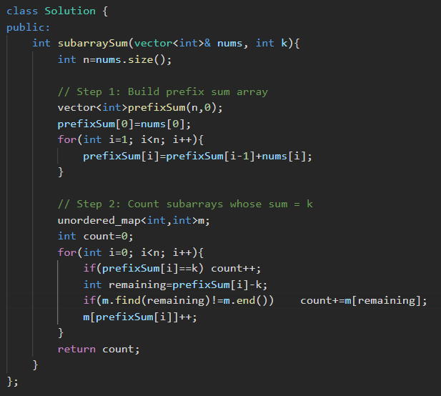

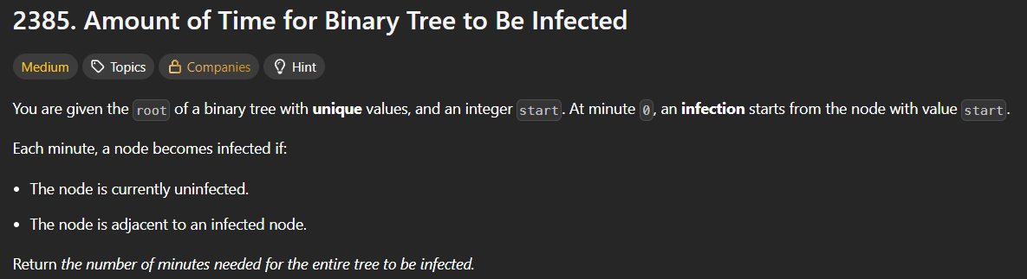 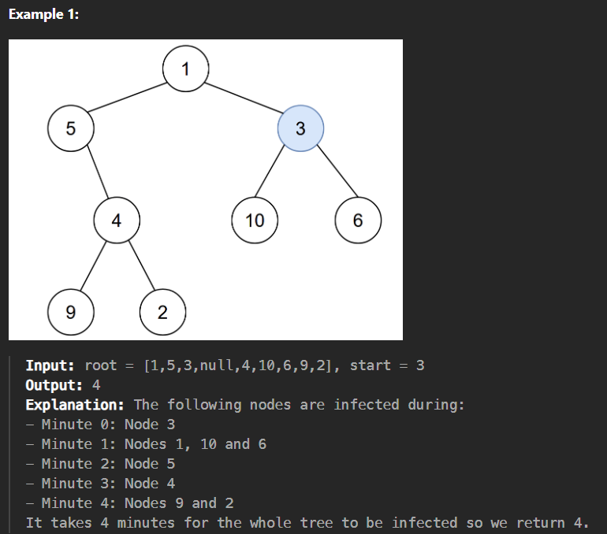

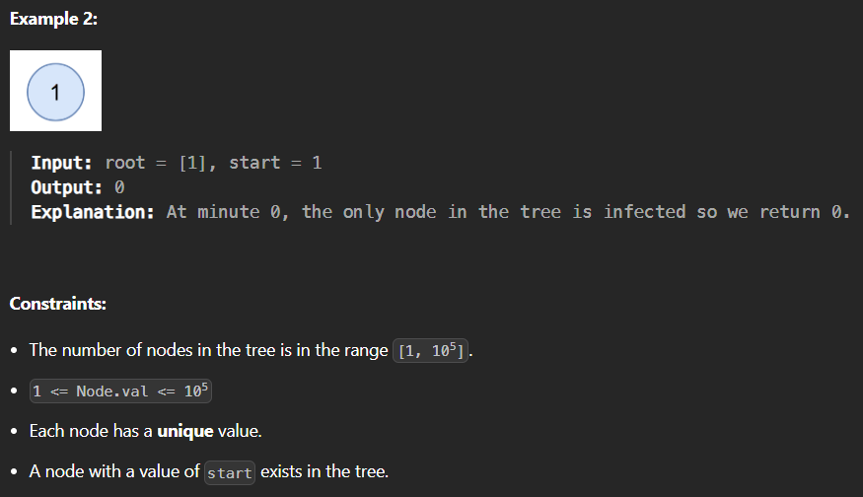

* 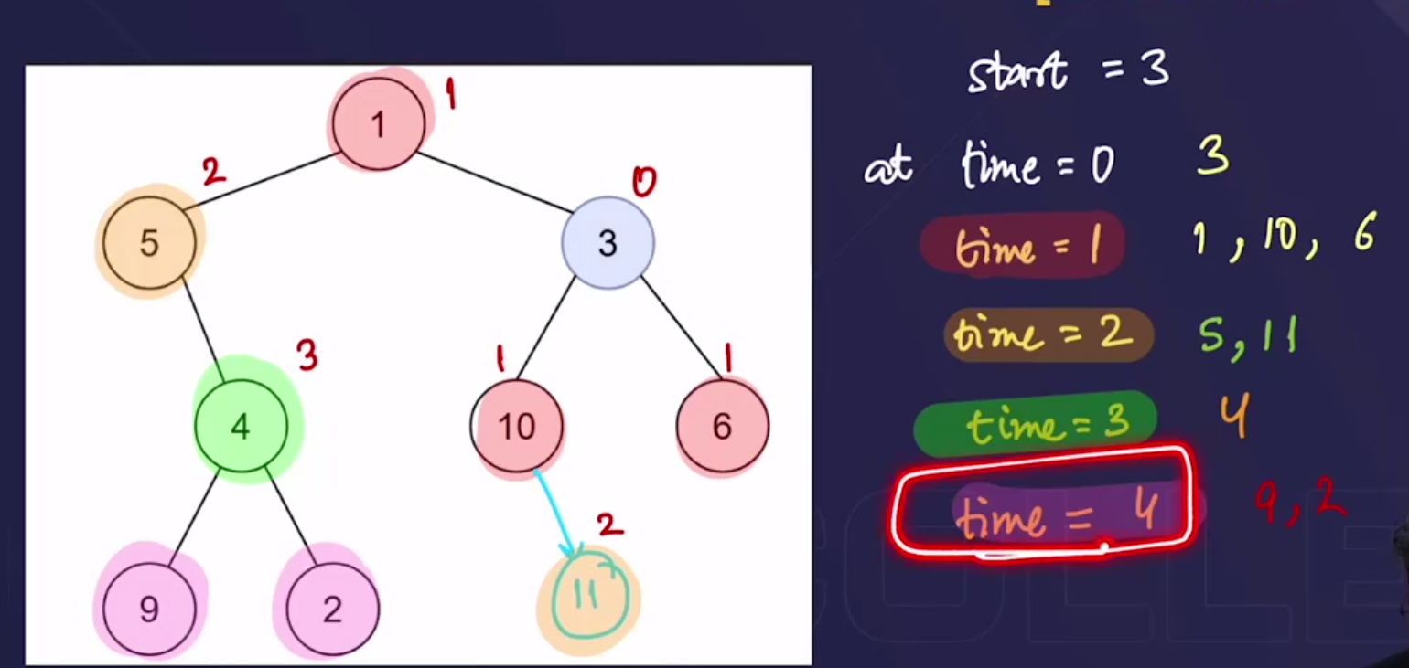

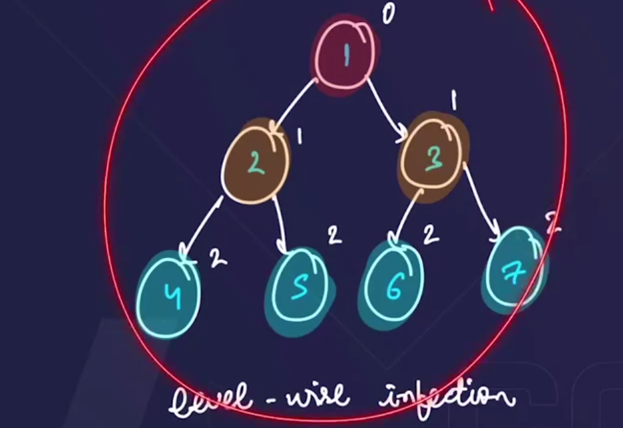

* Algorithm:

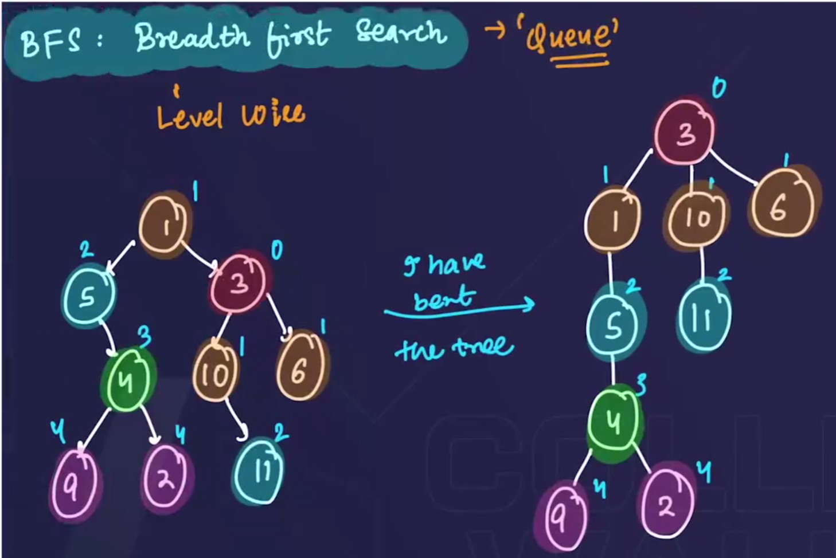

🡺question m given h ki 3 pehle infect hoga, so we will modify the tree with respect to the tree. Jo bhi nodes connected h , unko ek level wise laake rakho.

🡪at time=0, 3 infect hoga.

🡪at time=1, 3 se jo bhi connected h , who sb infect hoga.

🡪And so on……

🡺Note:🡪 here the amount of time required to infect the whole tree is equal to the (number of levels-1), by considering the infected node as the root node of the tree.

* 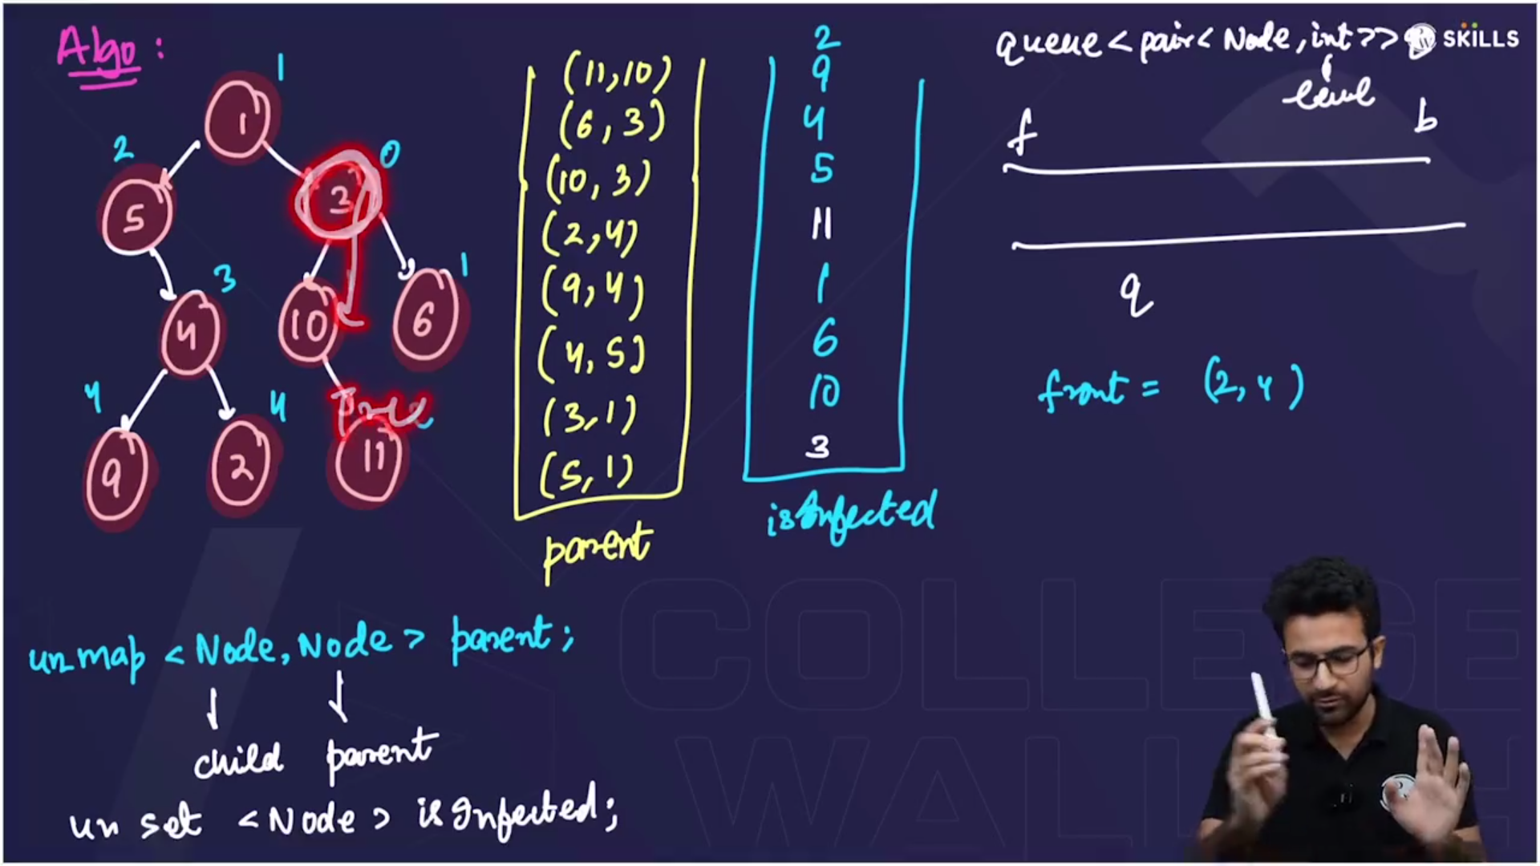
* 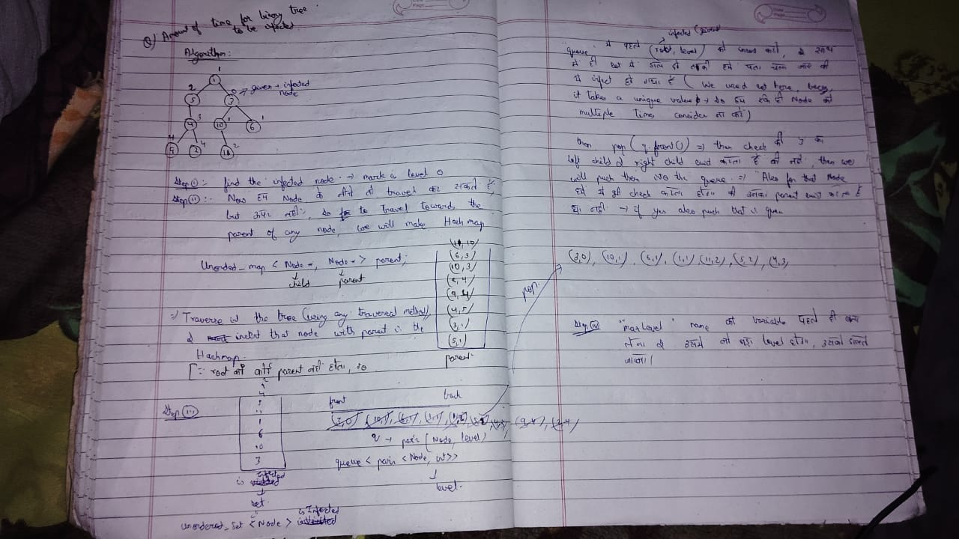
* 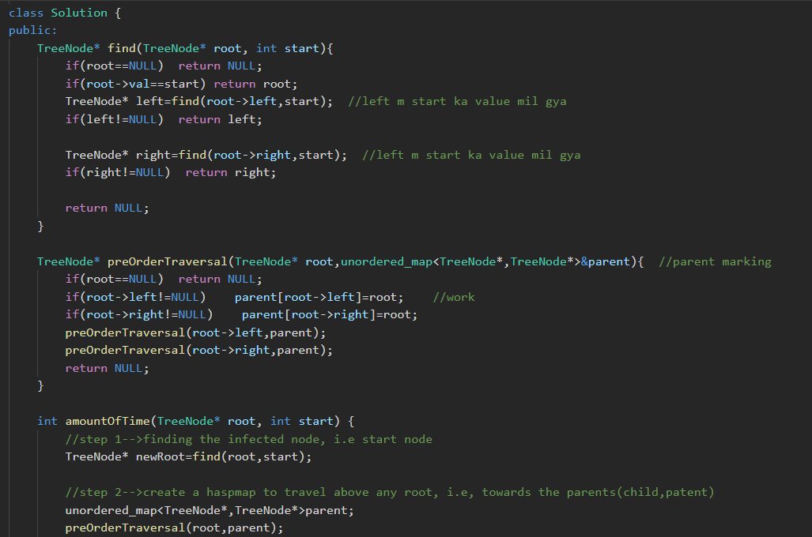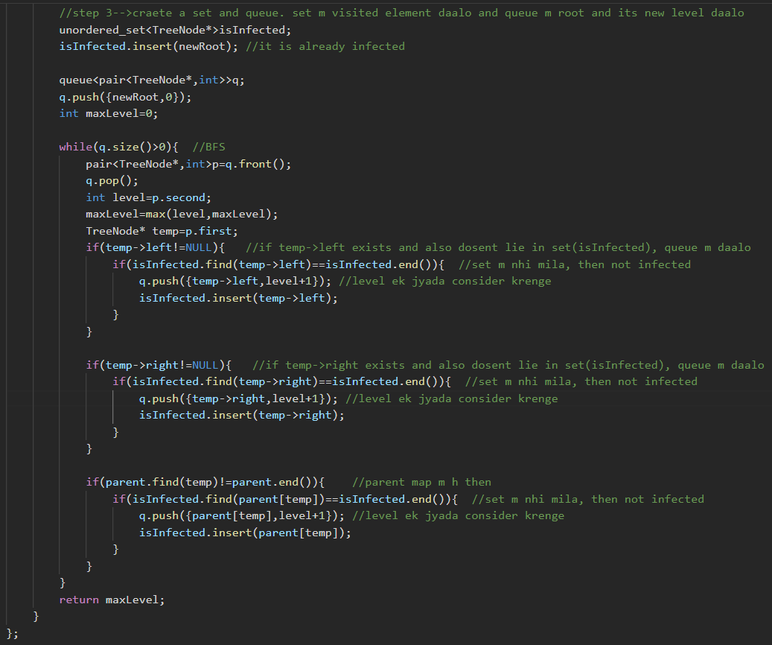

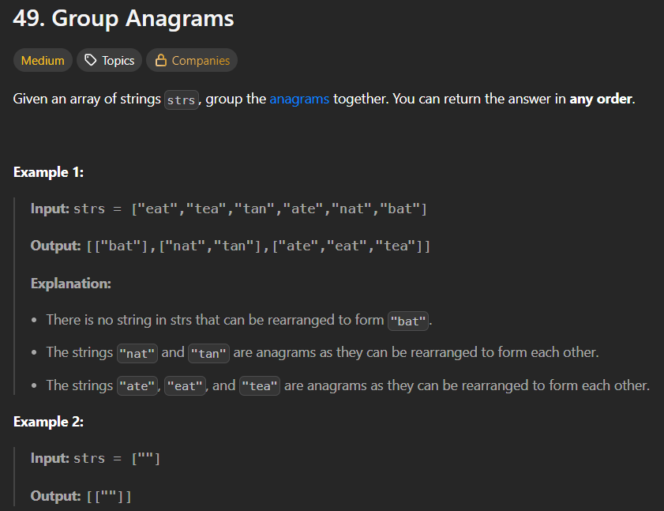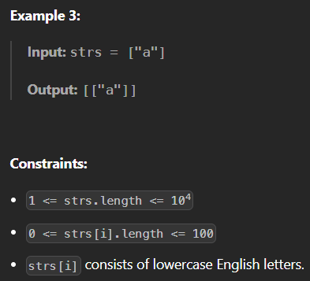

* Method 1🡪brute force🡪Time limit exceeded

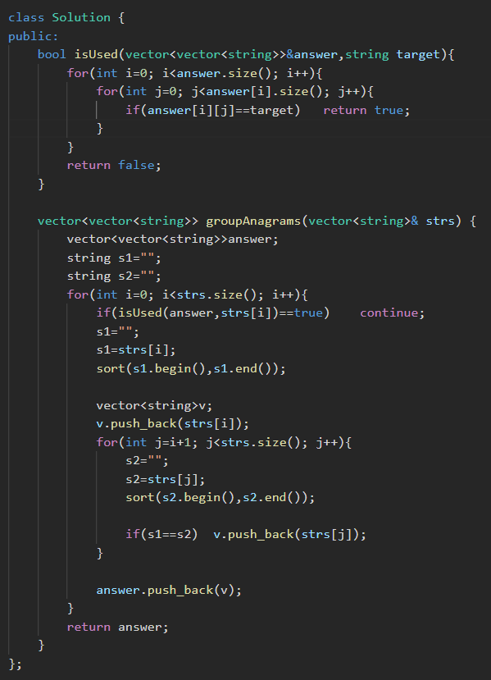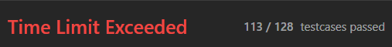

* Method 2🡪hashmap🡪Time limit exceeded

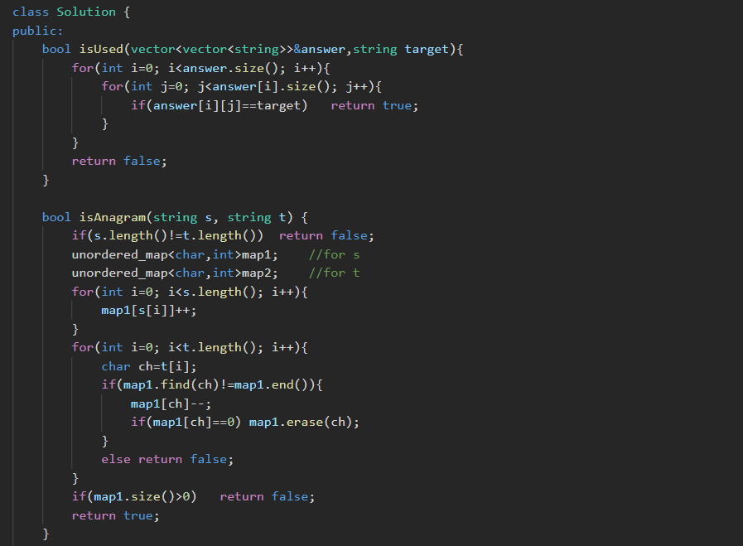 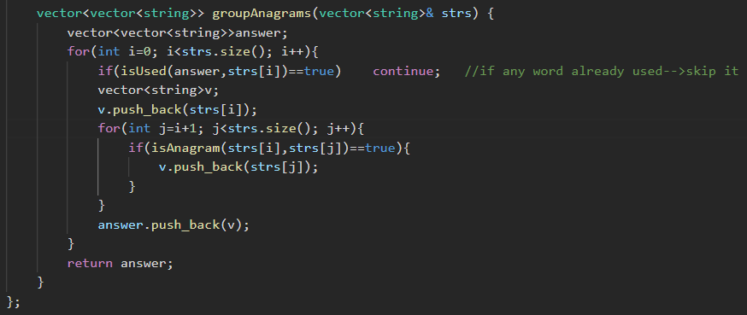

* Method 3🡪used haspmap🡪but used unordered_set to store used string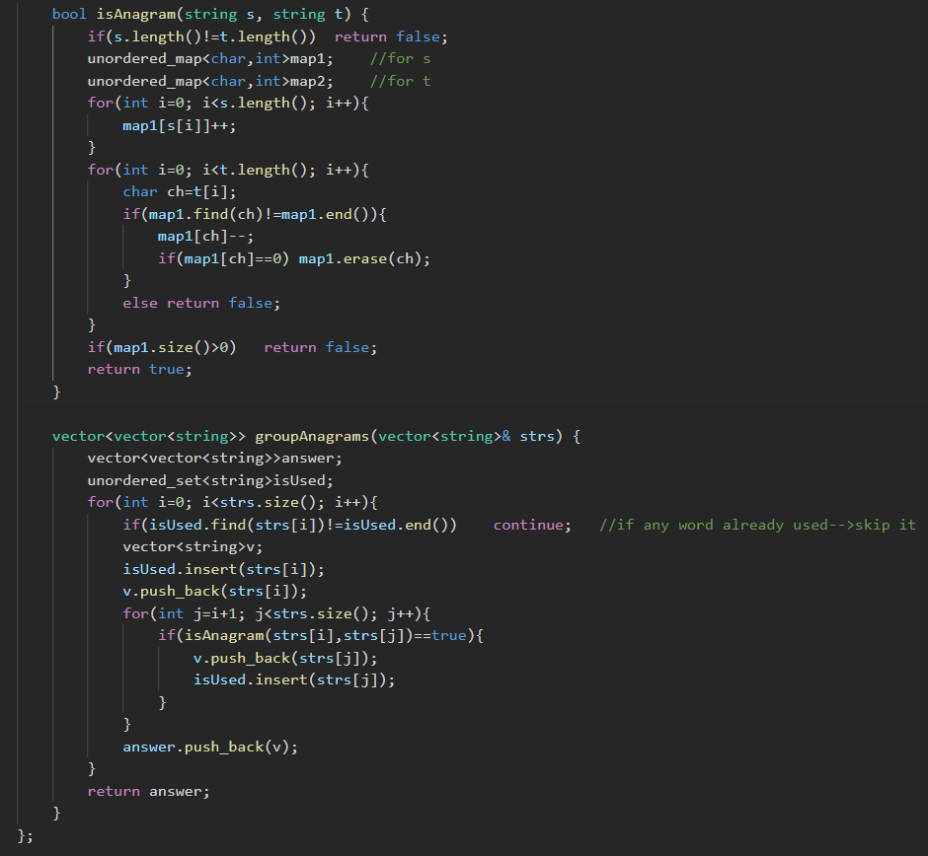
* Method 4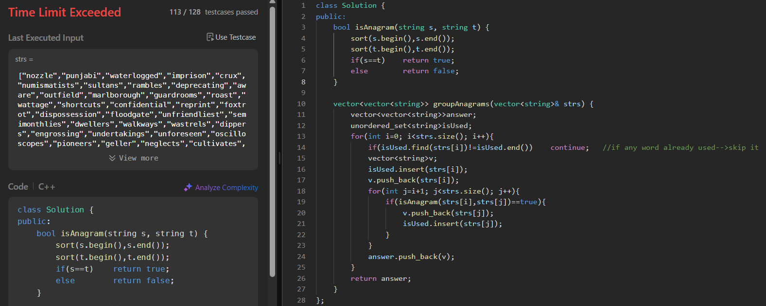
* Method 5🡪using hashmap(T.C=n. klogk && S.C🡪O(n.k), where k=length of the string) 🡪in which we will 1st sort the element and then insert in the map(in the key part), and ussi time vector m bhi push krwaa denge,
  + Then same for the 2nd element🡪sort it, then check ki, who pehle se present h ki nhi, if present h then vector m push krwaa do, and nhi h then create a new vector usme push krwaa do.

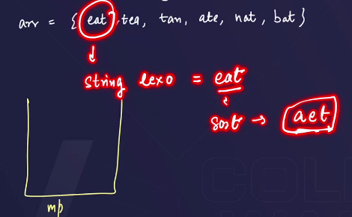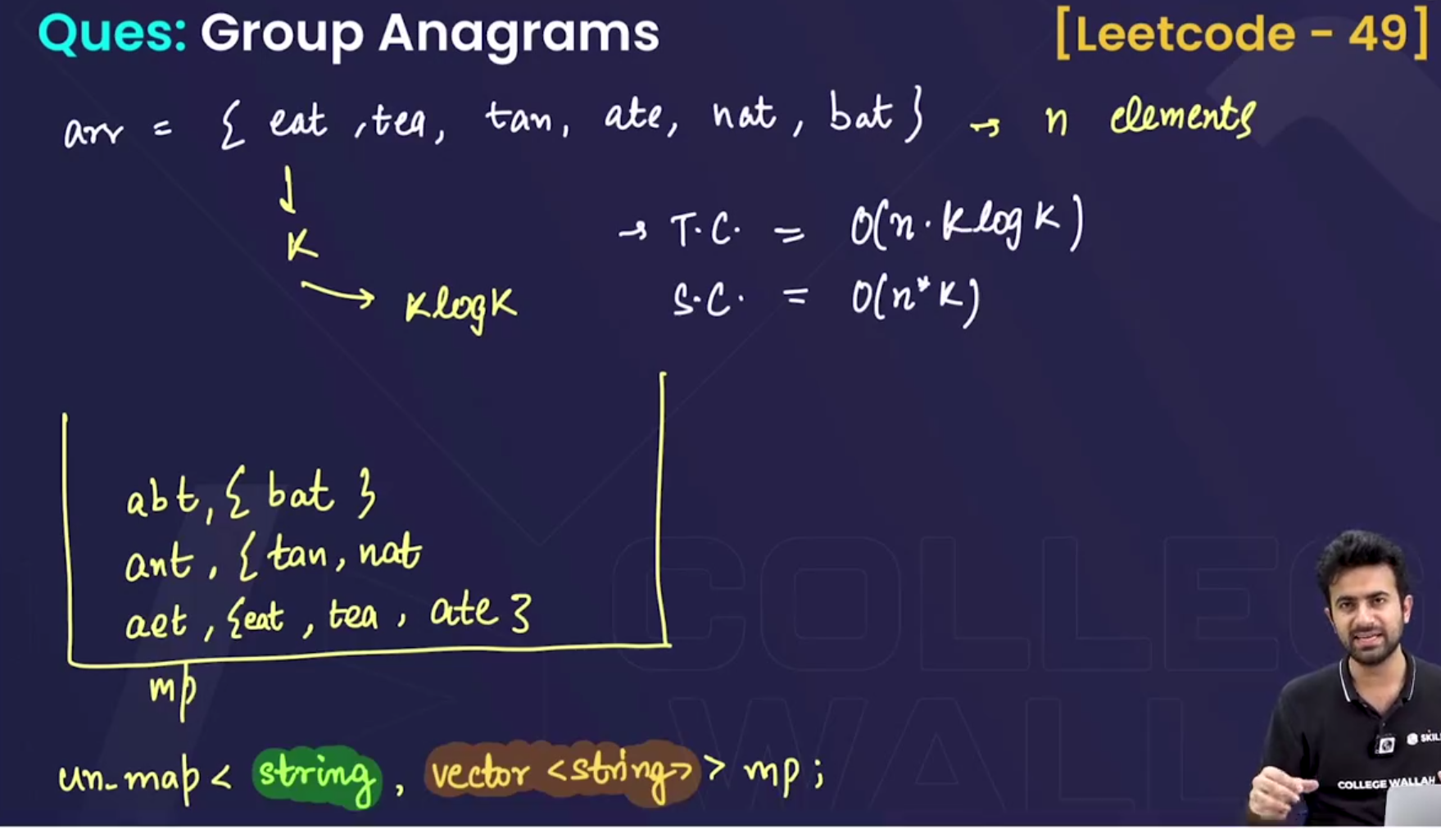c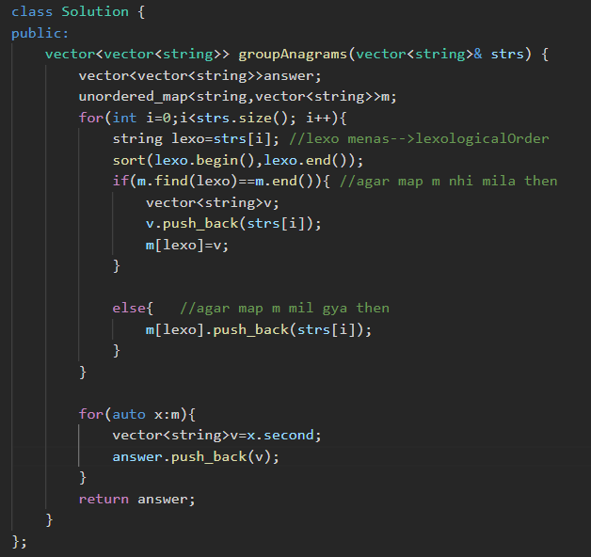

## 

* 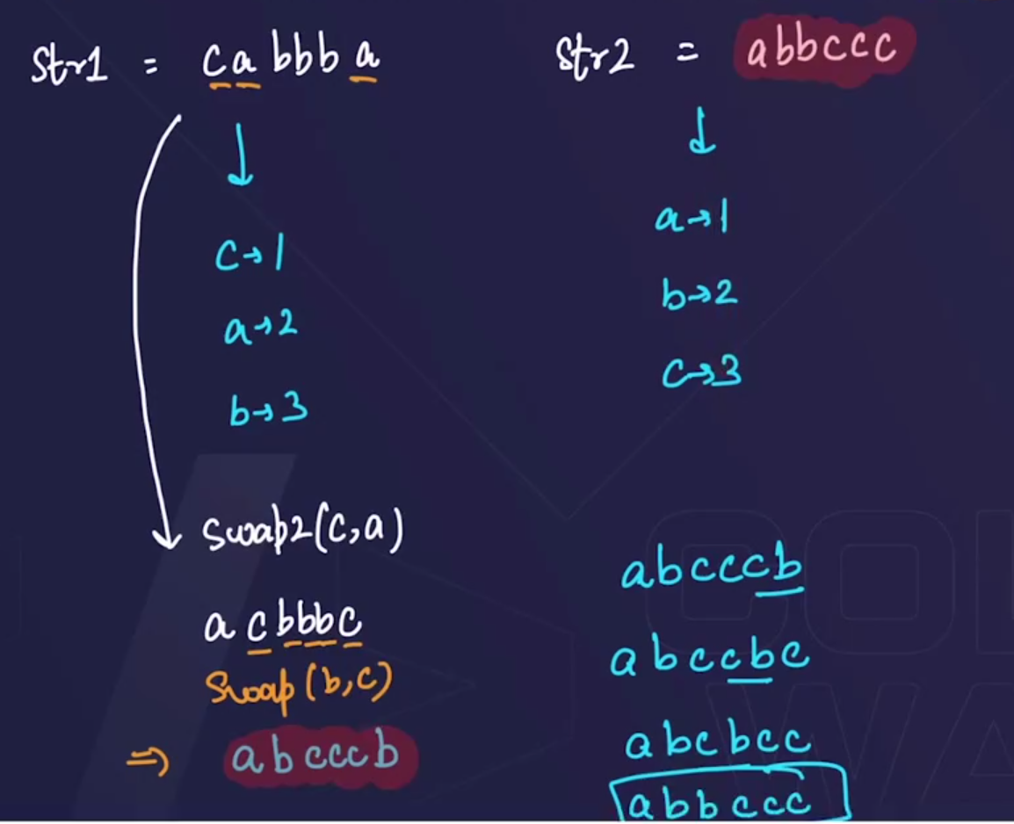
* Approach 1🡪
  + Pehle hm yehh check kr skte the ki, dono strings ka length equal h ya nhi, agar length hi equal nhi rha , then ek string se hm doosre string ko nhi bna skte h , i.e two strings are not equal.
  + And 2nd condition m yehh de skte the ki dono strings “Anagram” h, ya nhi, agar anagram hote then, hm ek strig ko doosre ki help se bna skte the🡪but this condition fails if the two strings have the charaters with different frequencies🡪so we will have to use hashmap here.
* Approach 2🡪
  + 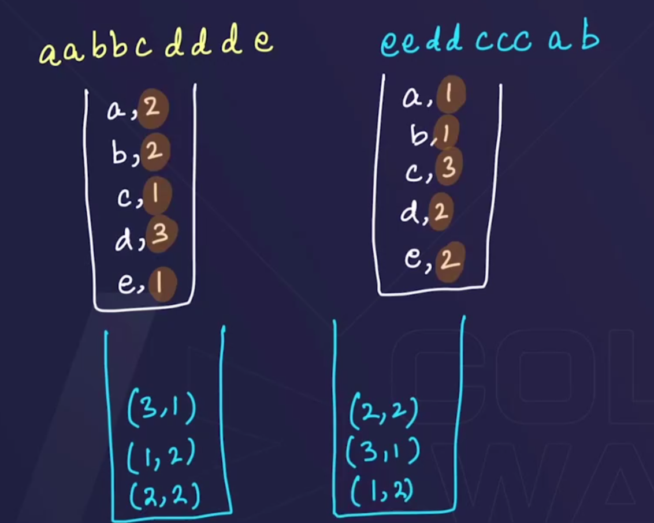
  + Pehle dono string k liye alag alag map bnaoo, and usme saare characters with their frequencies store kro.
  + Then again 2 hashmaps bnaoo and usme saare frequencies k frequencies ko store kraaoo (becoz if the frequencies ka frequency same hoga then, hm swapping k help se strings ko equal bna skte h), and if the maps of frequencies ka frequency , is equal then, we can say that strings are close. 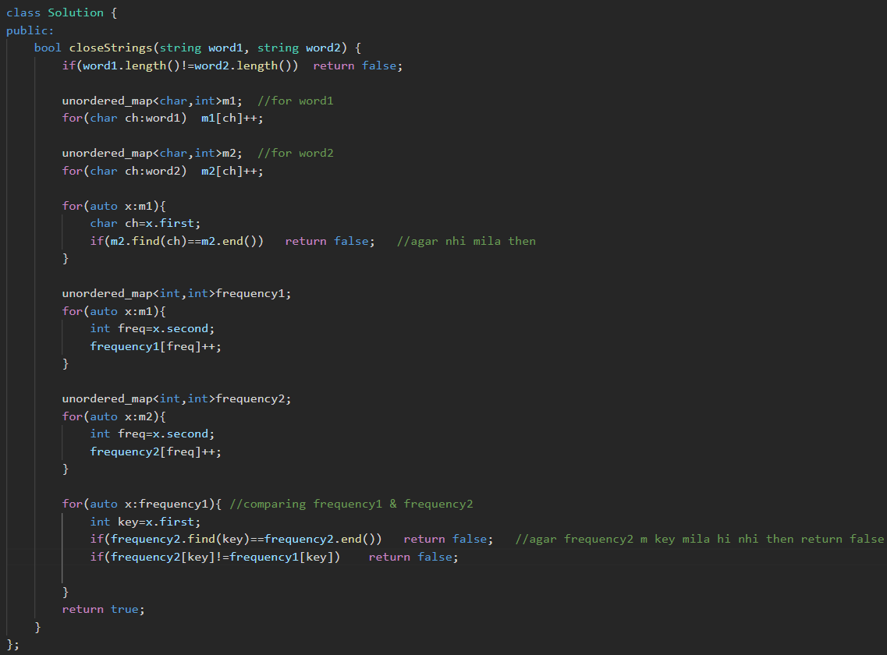

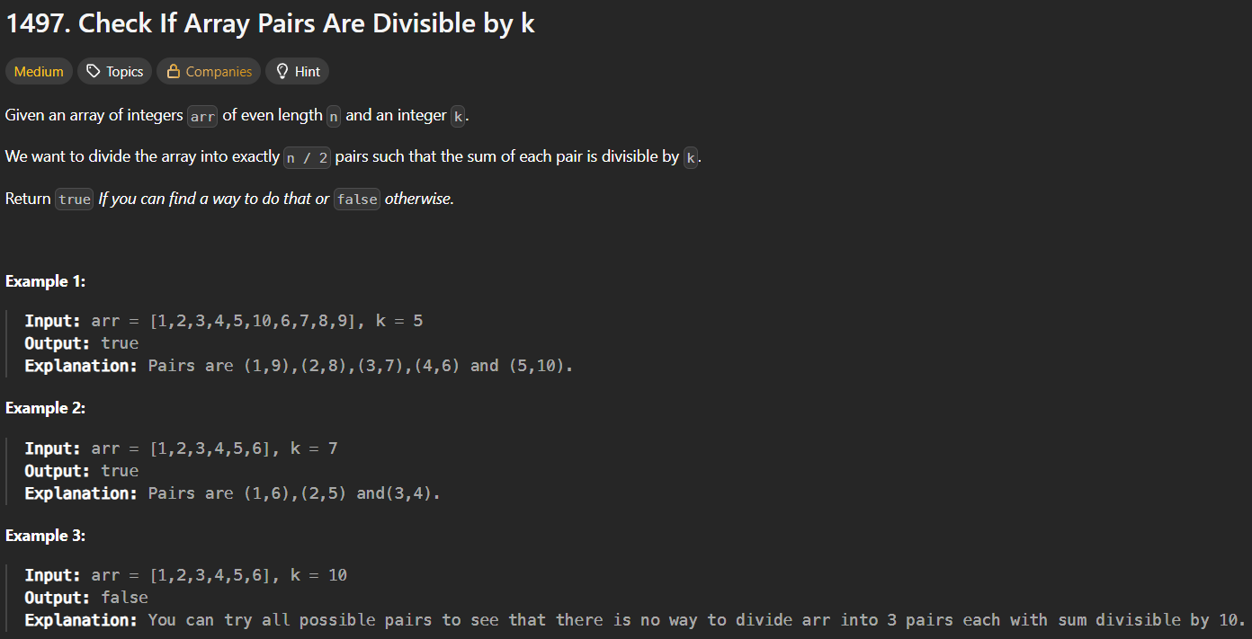 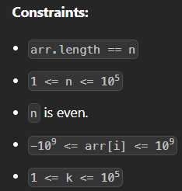

* 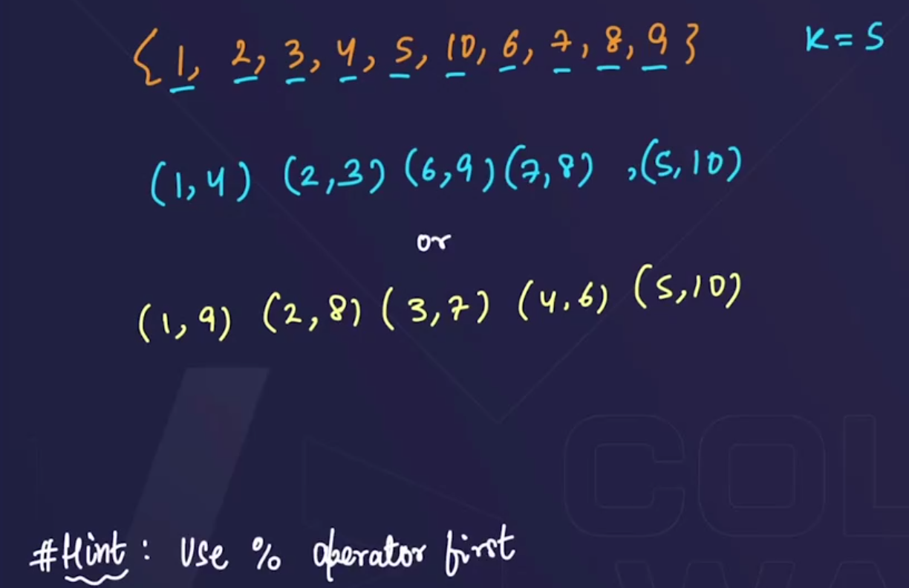
* 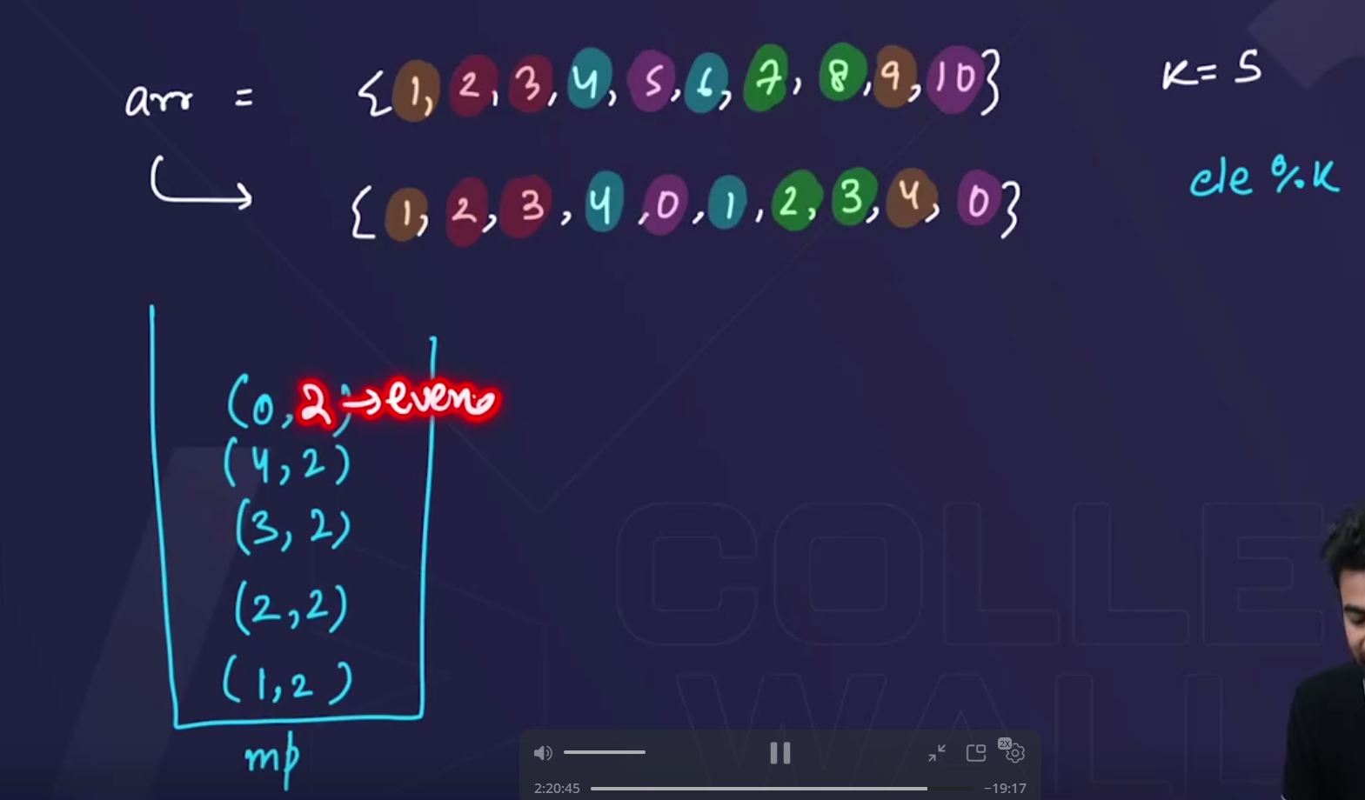🡪pehle ek array bnaaoo, and array k har ek element ko **ele%k** kr do and then map m daal do🡪map m har ek element with frequency jaayega🡪then for each element in the map **k-ele** kro and jo answer aayega usko check kro ki map m h ya nhi🡪 if h then pair bn jaayega, nhi to pair nhi bnega🡪and for 0 yehh check krlo ki 0, even number m present hona chahiye.
* 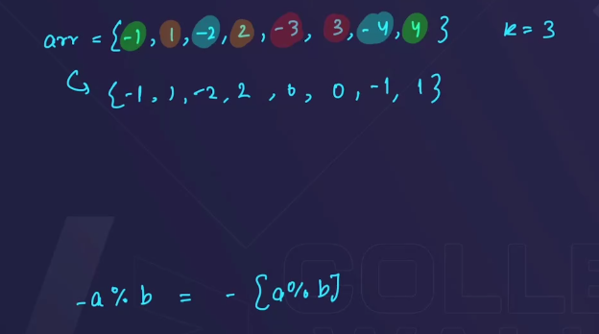🡪but problem is created in case of negative numbers

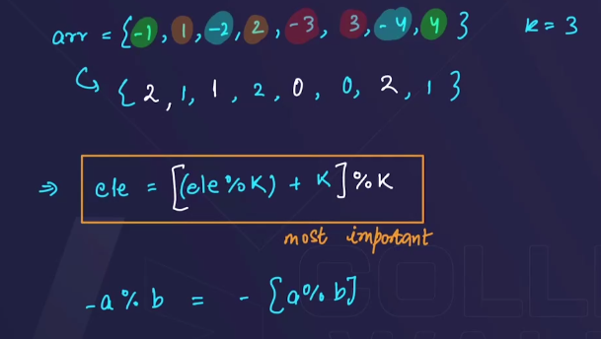🡪always true both in case of negative and positive numbers. 